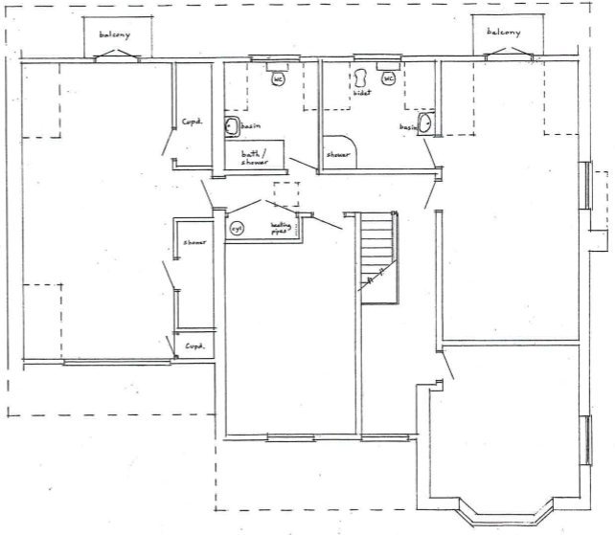
Bedroom Three
Bedroom Two
Bedroom One
Living Room

Maytree Lodge, 41 Roman Bank Spalding PE12 6EX
First Floor – current.

