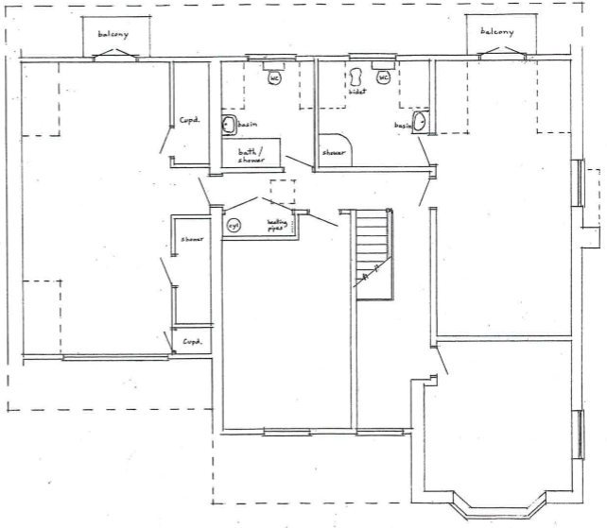
Baby Play Room
Kitchen

Office/Staff Room
Baby Rest Room
Baby Play Room

Maytree Lodge, 41 Roman Bank Spalding PE12 6EX
First Floor – proposed.

