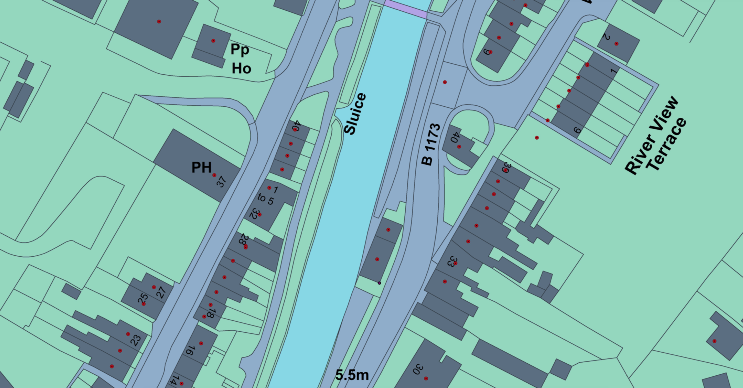
Chain Bridge Forge
Artwork location

