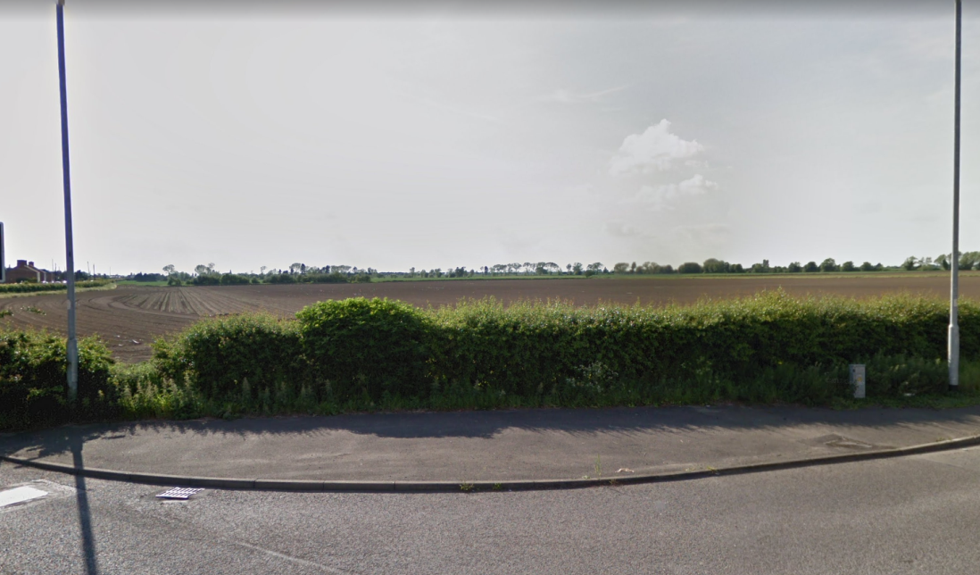
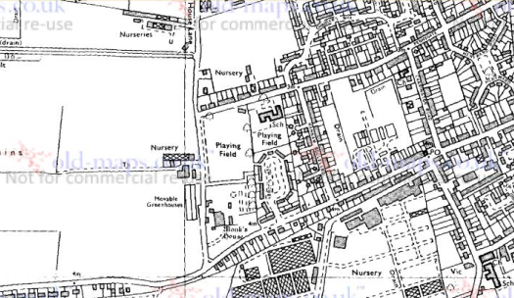
Unable to determine existence of hedgerow from historical OS maps 1982 or any previous historical maps.

