PLANNING STATEMENT
Certificate of Lawfulness application for House in Multiple Occupancy (HMO) at
24 Red Lion Street, Spalding, Lincs, PE11 1SX
for Mr George Tear.
September 2026

1.0 Project Details

Proposal: Certificate of Lawfulness for House in Multiple Occupancy (HMO).

Location: 24 Red Lion Street, Spalding, Lincs, PE11 1SX.
Client: Mr George Tear.

Local Planning Authority: South Holland District.

Date: 28th September 2026.

2.0 Introduction

2.1 This report has been prepared as part of this application for a Certificate of Lawfulness for the current sui generis use of the building. It will endeavour to provide the necessary background and rationale to justify the proposal.

2.2 The property is a grade II listed building and so the submission also includes a Heritage Statement which considers the significance of the heritage asset, any potential impacts on historic fabric, as well as the setting of the conservation.

2.3 The document should be read in conjunction with the survey and design drawings provided by the applicant.

3.0 Background

3.1 The applicant purchased the property and adjacent bakery (which had ceased to trade) in 2014. Since that date he has successfully re-established Paceys Bakery, which has recently expanded its commercial offer with the addition of a first floor restaurant and additional seating now available on the ground floor.
3.2 As the adjacent dwelling was no longer required for the use of the business, the applicant approached South Holland District Council with a view to renting out rooms. Following on from those initial discussions, it has been licenced by SHDC as an HMO (ref HMO/0165) for almost 12 years. The third 5 year licence (under section 64 of the Housing Act 2004), was granted 10th March 2025 for a maximum of 7 residents.
3.3 As advised by the Senior Housing Standards Officer and Building Control at the time, the only requirements were the installation of the mandatory fire and smoke alarms, automatic door closers for each bedroom and the painting of each door with intumescent paint, all of which were duly completed.
3.4 Currently part of the ground floor of the house continues to be used as storage for the bakery. This room is accessed primarily from the courtyard. There is also a second door on the front elevation.

4.0 Purpose of the Application

4.1 This application for a Certificate of Lawfulness (CLEUD) seeks to establish that this existing development (i.e. use of the property as a H.M.O.) is lawful for planning purposes. In effect a formal confirmation from SHDC that the use and operation of an HMO at the property is lawful and immune from enforcement action.

4.2 The current licence for this 6 bedroom property allows for a maximum of 7 residents who share a communal kitchen and bathroom on the first floor and a second toilet off the landing between the first and second floors. Bedroom 2 has its own ensuite bathroom with a toilet, shower and bath.

5.0 Local Plan Policy Requirements

5.1 The South East Lincolnshire Local Plan, covering Boston Borough and South Holland, was adopted in March 2019. The following policy is relevant to this application:

Policy 21 Houses in Multiple Occupancy & the Sub-Division of Dwellings.

5.2 The policy references the definition of a house in multiple occupation (HMO) as defined by the Housing Act 2004. Essentially that it is a building or part of a building that is rented out by at least three people who are not from a single household and who share some of the facilities. Another important consideration outlined in the introduction to the policy is that HMOs with six or more residents are not classified by the Town & Country Planning (Use Classes Order (1987) and are therefore sui generis and consequently require planning permission.
5.3 For ease of reference, the relevant policy and its requirements is quoted in full below. The specific response to each numbered criteria is then given in Section 6.

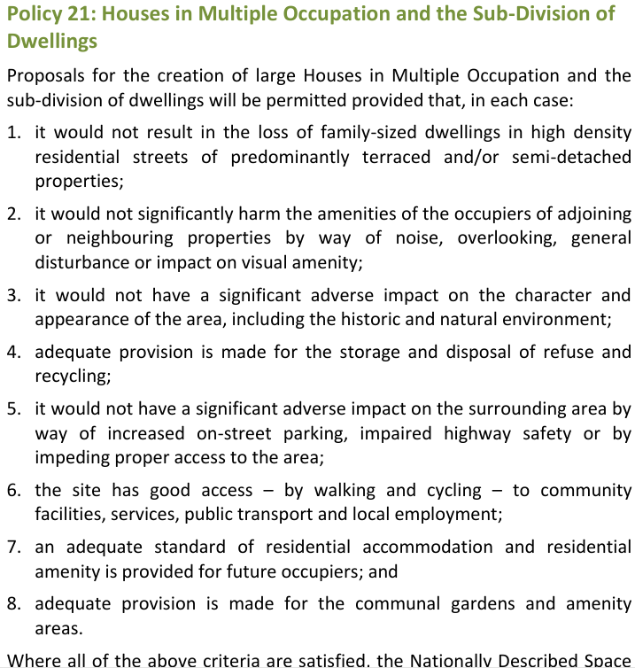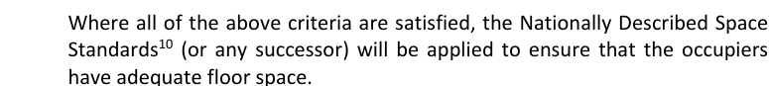

6.0 Response to Policy 21 Criteria
- Whilst no. 24 is clearly a family sized dwelling it is located in a primarily commercial area in the town centre. The neighbouring property to the right is the Boston College building and adjoining to the left is Paceys Bakery.
- There are no residential properties in close proximity and so it is extremely unlikely there would be any impact on any residential amenity.
- There are no planned changes to the exterior of the listed building and consequently no impact on the setting of the conservation area.
- The HMO has operated successfully for almost 12 years with no specific issues relating to refuse and recycling.
- The property is located in the town centre with a wide range of services available. Car ownership is therefore unnecessary and given the type of accommodation unlikely. Whilst admittedly there is no off street parking, this has not tended to be a problem for tenants, most of whom are not car users. Those that may have a car can make use of a number of public car parks within a 5 minute walk. There have been no parking issues relating to the property over the last 12 years. In addition to this parking restrictions apply to Red Lion Street.
- As noted under item (5), The property is located in a truly sustainable location with a full range of services accessible on foot.
- The fact that the HMO has been licenced by the Senior Housing Standards Officer for the third time clearly demonstrates that a satisfactory level of accommodation and amenity is provided for up to 7 residents. The property is therefore in accord with all the statutory requirements for space standards, amenities and fire safety (see SHDC’s Appendix C Amenity & Space Standards for HMOs 2026-2029).
- The property is situated on the back edge of the footpath in a densely built up area. The adjacent courtyard is used by the business for access and outdoor covers. Given these constraints there is no garden or outdoor amenity space available. There is, however, seating in the marketplace, the Riverside Park and Ayscoughfee Gardens, all within a 5 minute walk. Given the comparatively low cost of the rooms there has been no shortage of occupants.

7.0 Conclusion

7.1 The property has been licenced by the District Council for almost 12 years. The established use as an HMO provides well-appointed and affordable rented accommodation in a well serviced and sustainable town centre location. It is well managed by the owner who lives nearby. There is no history of neighbour nuisance or any antisocial behaviour caused by tenants. Its use as a house in multiple occupancy did not require any significant interventions to the historic fabric of this listed building, which therefore remains unaltered and intact.

JB/29 September 2026.

