Tuin Log Cabins

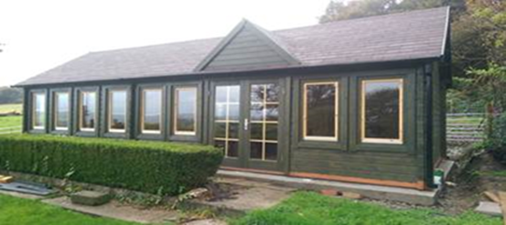

This is the heavy-duty model log cabin with 70mm thick walls. Most others are 27mm or 44mm. This size is 9.3m x 4m.

The Lauren two room Clock house Log Cabin features as standard:
- 70mm interlocking wall logs
- Conical tongue and groove for stability
- Double glazed
- Two internal rooms
- Two Double door sets
- Ten windows
- Quality door and window fittings
- Real glass
- Roofing felt or FREE shingles
- Tanalised foundation beams
- Fixing kit and instruction manual
- Wind and watertight connections
- 28mm Tongue and Groove Roof Boards
- 28mm Floor
Dimensions:
- Overall Dimensions: 9.30m x 4.0m
- Building Footprint: 9.10m x 3.80m
- Ridge Height: 3.51m
- Eaves Height: 2.23m
- Door Height (including frame): 1.93m
- Overhang: 0.20m
Internal room size:
- Room One: 3660 x 5160mm
- Room Two: 3660 x 3730mm

