- Drive View – Existing double skin Wall
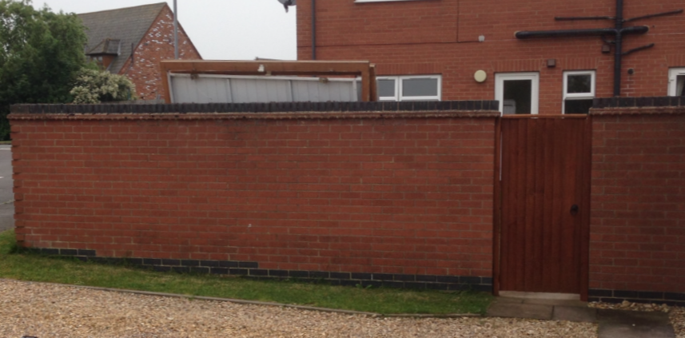
2m
- Drive View - Proposed Step Increase of 150mm at A. Max Height <2m
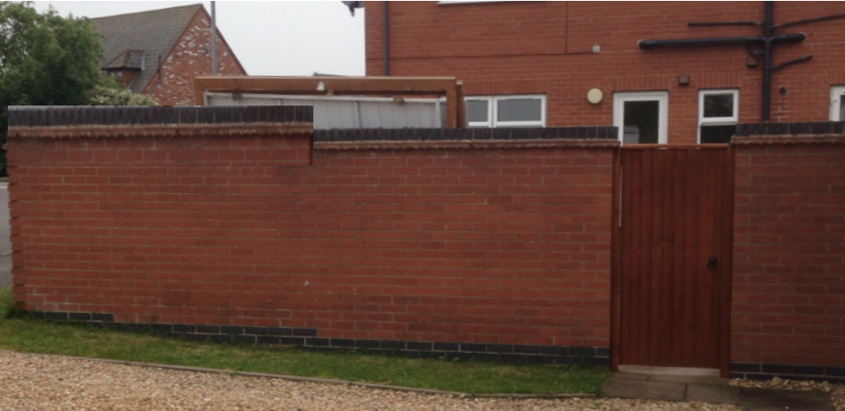
A= 2m
2.7mm
- Side View Existing
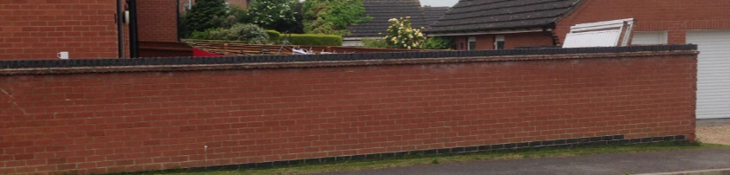
- Side View – Proposed Stepped increase at :
A= 150mm. B = 300mm C= 450mm. Max Height 2m
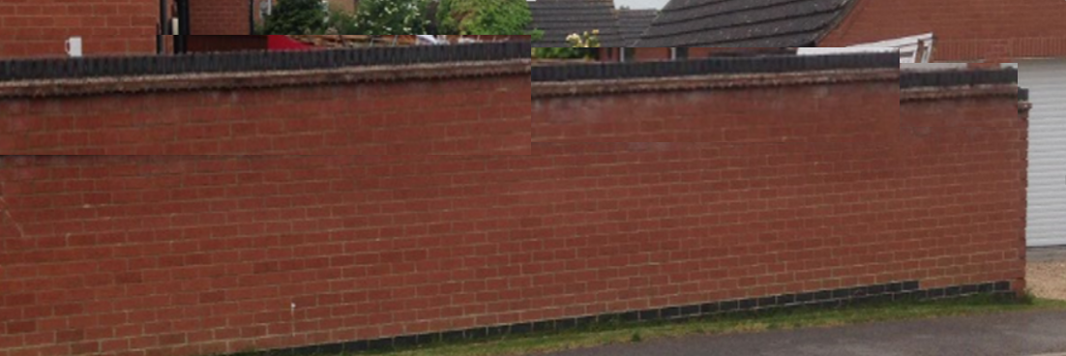
A=300mm L
150mm increase
C = 450mm increase
B = 5m Length
300mm increase
Max 2m Height
2m

- Front View Existing
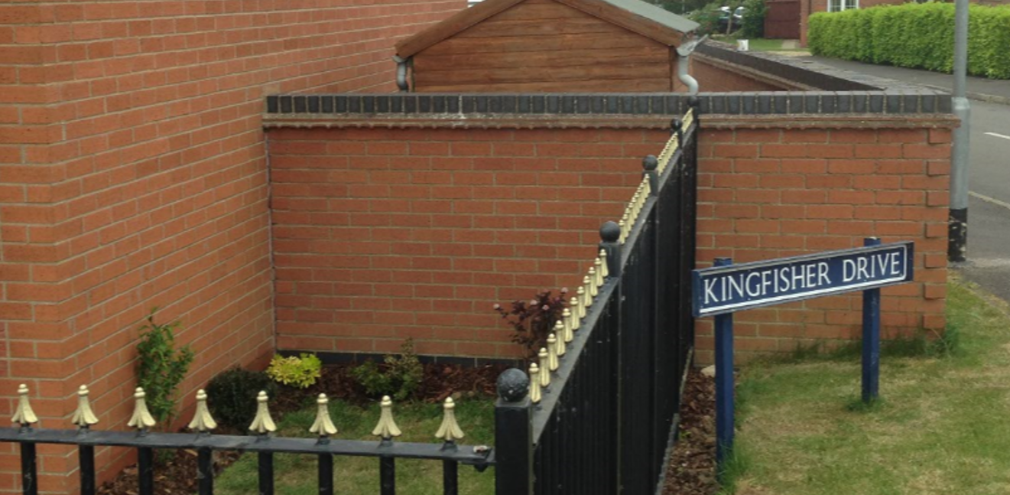
- Front – Proposed increase c450mm Max Height <2m
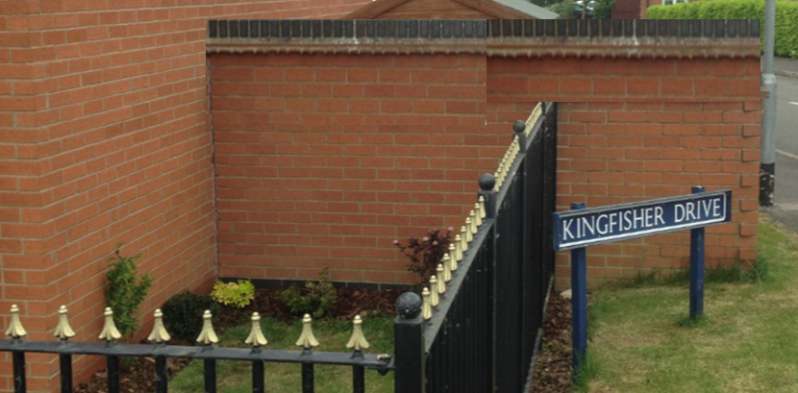
C = 450mm increase
2m

