DESIGN AND ACCESS STATEMENT: PROPOSED REPLACEMENT SINGLE STOREY HOUSE AT THE RIVER HOUSE, 6 THE RESERVOIR, SURFLEET SEAS END, SPALDING, LINCOLNSHIRE PE11 4DJ

The site
The site, which currently contains a single storey house that is to be demolished, is one of a row of sites that line the River Glen at Surfleet Seas End. The site of number 6 is on the north bank, and it is accessed via a track that serves each house, with the houses on the south side of the track and garages or other outbuildings on the north side.
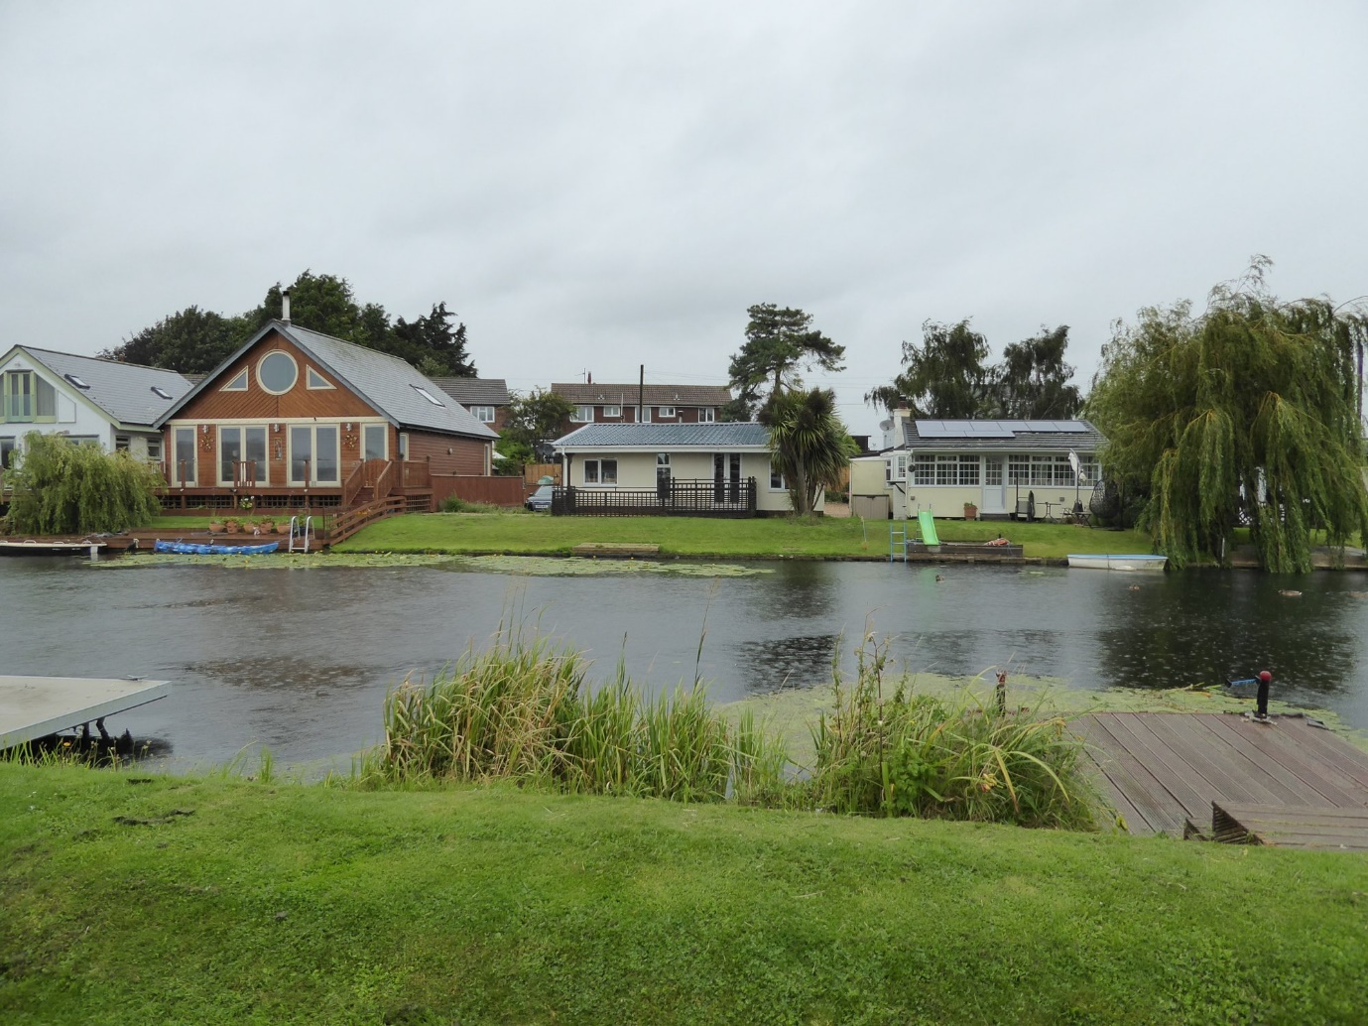
The above photograph shows number 6 central, with number 5 to the left and number 7 to the right.
Planning history
While we know of no planning application made in respect of number 6, Chris Douglas, the applicant, was also the applicant in connection with application H17/0867/08 relating to the building next door at number 5, which was granted planning permission on 5th August 2008. Chris had to move to Nottingham and sold number 5, but he recently found himself in a position to be able to return to Surfleet Seas End and he bought the site of number 6.
As the site of number 6 is pretty much identical to the site of number 5 in terms of its position in relation to the river and to flood risk, site knowledge has proved invaluable in progressing the design for number 6.
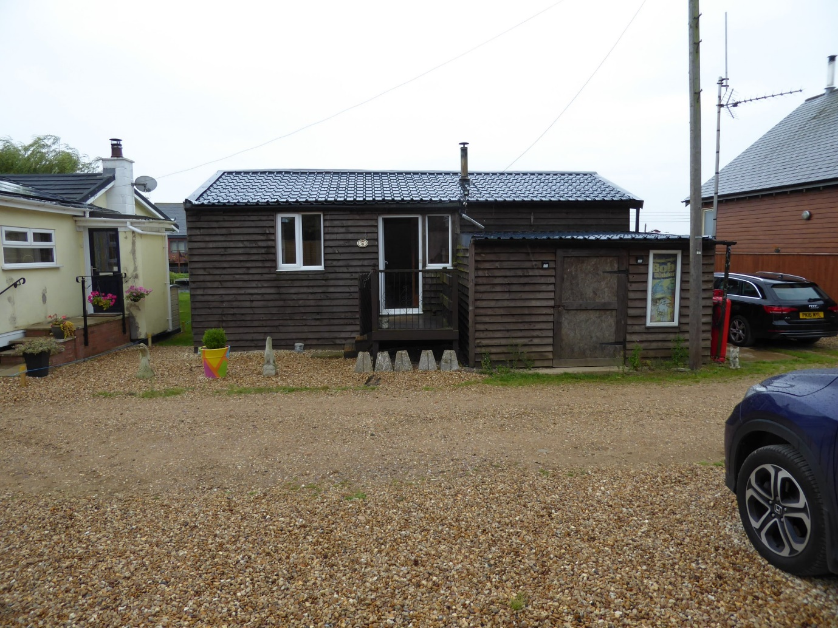
The photograph above shows the rear of number 6, with number 7 to the left and number 5 to the right. The photograph is taken from the part of number 6’s site on the other side of the access track, which is visible as a slightly smoother surface than the gravel in the foreground.
The proposal
A combination of the ground floor level needing to be lifted to a height required for flood risk and the need to insulate the building at least to current Building Regulations standards means that a rebuild is necessary.
The proposed building will remain single storey, the ground floor being raised 1200mm above the required datum for flood risk as is number 5, and it will be timber clad, as is number 5.
Because number 6’s site is wider than number 5’s, a dual pitched roof would naturally be at ninety degrees to number 5’s roof, and there was concern that this might make the proposed building look too bulky on the site. Hence we’ve opted for a monopitch zinc roof, which allows us to keep the height of the building down.
The joy of this site is that it faces south towards the river, so the south side is naturally where the bulk of the windows are. At this latitude, a large amount of glass on the south façade is an environmental plus as considerable space heating is passively gained from the sun. Having a shallow pitched roof allows the south side of it to project, which gives shelter to the deck on the river side and at the same time provides the necessary shade from intense summer sun while allowing in the warmth of winter sun. Hence the roof does three jobs in one.
Keeping with the tradition of the locality, a replacement garage is proposed for the part of the site on the opposite side of the access track. Here there is also space for additional parking.

Environmental issues
In developing the design for number 5, the Environment Agency was consulted regarding safety from flood risk and prevention of increasing flood risk elsewhere. All advice given was taken and implemented, and the same applies to number 6.
As with number 5, number 6 will be built to high insulation standards – in excess of Building Regulations requirements – and again as at number 5 the proposal includes both types of solar panels: solar photovoltaic and solar thermal. At number 6 we’re taking advantage of the south facing roof slope of the proposed garage, which is large enough to accommodate all the necessary panels.
All in all we shall have a very energy efficient building. Number 5 came second in the LABC awards for the year it was built. We hope to go one better with number 6.
Access
As the building needs to be raised above flood risk levels, ramped access needs to be provided, and this is incorporated in the design.
Enhancing the site
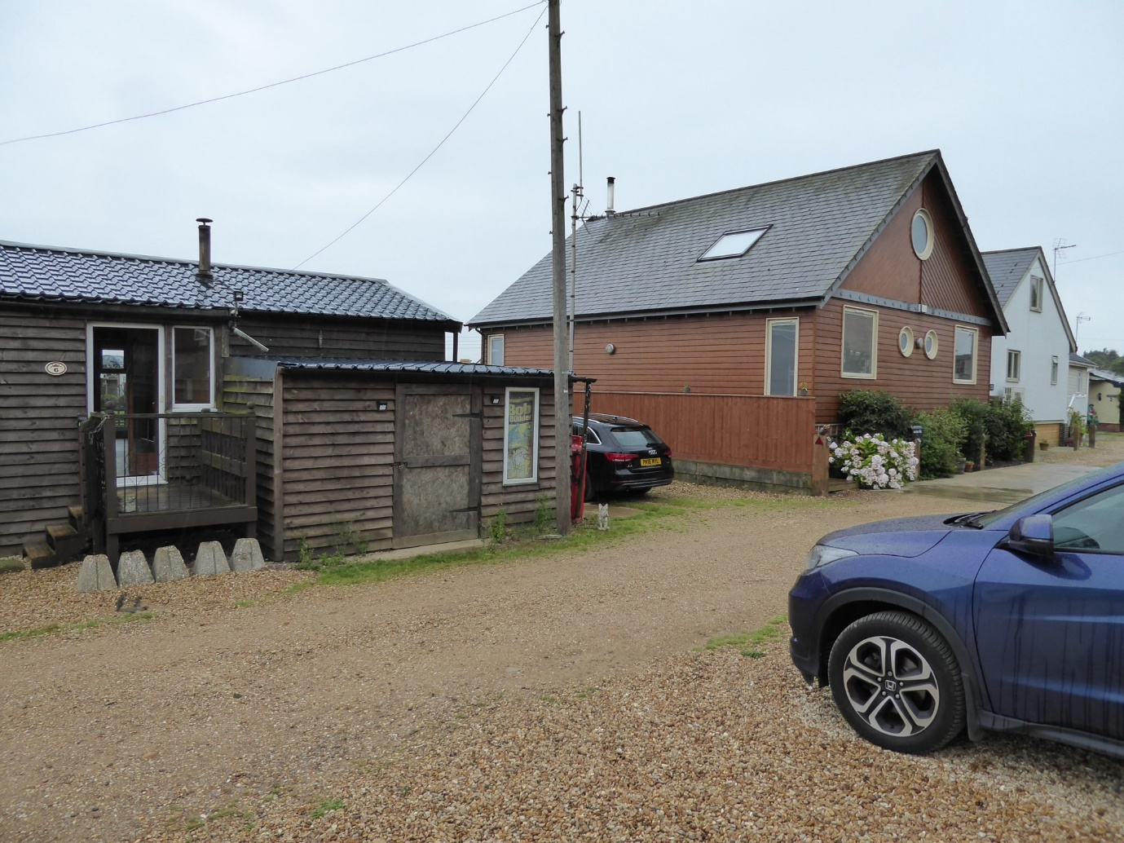
The above photograph shows how the existing house at number 6 has been added to in an unattractive, agglomerative fashion. The proposal simplifies the plan form, resulting in a much neater building. In addition, the applicant has already instructed the telegraph pole to be re-sited behind the proposed garage and lines from it run underground to the house. This has already been done, resulting in the removal of visual clutter from the scene.
The applicant will also introduce planting to number 6 as he did at number 5, as can be seen in the above photograph.
Conclusion
Recent rainfall has put number 6 at serious risk of flooding. The proposal takes away that risk, the house being raised to a level recommended by the Environment Agency, and at the same time a considerably more attractive building will occupy the site. We hope that the LPA agrees and can support this application.

