DESIGN STATEMENT: PROPOSED ART STUDIO AT 6 THE RESERVOIR, SURFLEET SEAS END, SPALDING, LINCOLNSHIRE PE11 4DJ

The site
The site, one of a row of sites that line the River Glen at Surfleet Seas End, contains a house and a garage that were granted planning permission in December 2019 under application H17-1066-19. The site of number 6 is on the north bank of the river, and it is accessed via a track that serves each house, with the houses on the south side of the track and garages or other outbuildings on the north side. The section of the track that crosses the site is owned by number 6, with right of way across it granted to other occupants of The Reservoir.
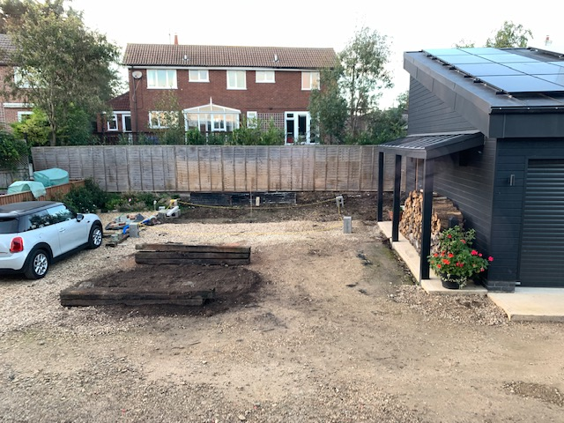
The photograph above shows the site of the proposed studio looking north, with the access track in the foreground. The house in the background is on a neighbouring plot to the rear that is raised above the proposal site. The difference in levels is better shown in the photograph on the following page,
The proposal
The proposal is for a simple, single storey building to be used as an art studio by the owner of number 6, and it is to be set alongside the garage in the above photograph. Currently this part of the site is vacant as the above photograph shows. The building will be set towards the back of the area in the photograph, leaving the length of a car parking space between it and the access track.
In design terms simplicity is the key, with dark materials being used to match those of the house and garage on the plot. A duo-pitched roof is proposed for the studio, and we feel that black corrugated metal sheeting would better suit such a roof than the zinc sheeting used on the mono-pitch roofs of the house and garage. Windows and doors would match those of the house, as would the proposed deck to the side of the building. Please see elevations drawing SU3.02F.
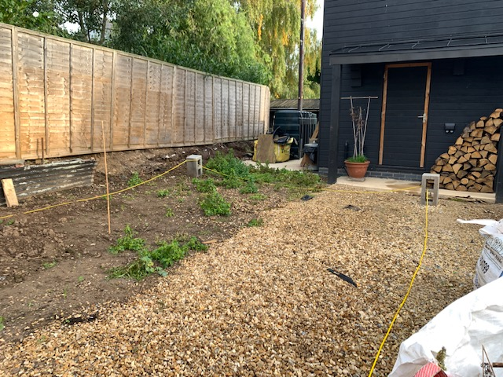
The photograph above illustrates the rear of the site and the level drop between the plot to the north and the proposal site. The yellow lines indicate the footprint of the proposed building.
In terms of privacy, the proposed studio, with its absence of windows on the north side, will actually increase privacy between the proposal site and the neighbour to the north without taking away any sunlight from that neighbour’s garden.
Environmental performance
The studio would be constructed using insulated timber framework for the walls, and there would be high levels of insulation in the floor and roof. Windows and doors would feature double glazing and very low air leakage. In other words, a fabric first approach to the environmental design of the building would be used.
As the proposed building is not designed for habitation it is not proposed to raise it above the ‘one in a thousand year event’ flood level. Rather its floor level is set well above the height of all recent flood events. (Please see the accompanying flood risk assessment.)

Car parking
Site layout and plan drawing SU3.01F, which accompanies this enquiry, shows that the proposal results in no loss of parking spaces.
Conclusion
We believe that our proposal adds to the locality without taking anything away, and we hope that the Local Planning Authority agrees with us.

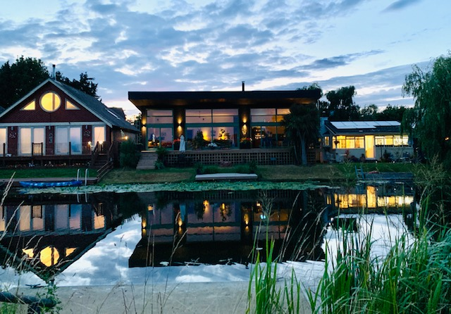
The above photograph showing the house and its neighbours from the other side of the river illustrates how the proposed studio would barely be visible from anywhere other than its immediate vicinity.

