Ref: 4159-23

APPLICATION FOR PRIOR DETERMINATION NOTIFICATION OF A PROPOSED CHANGE OF USE OF AGRICULTURAL BUILDING TO DWELLING

S E KING BUILDING CONTRACTORS LTD

MAZE FARM, HOSPITAL DROVE, LONG SUTTON, LINCS, PE12 9EN

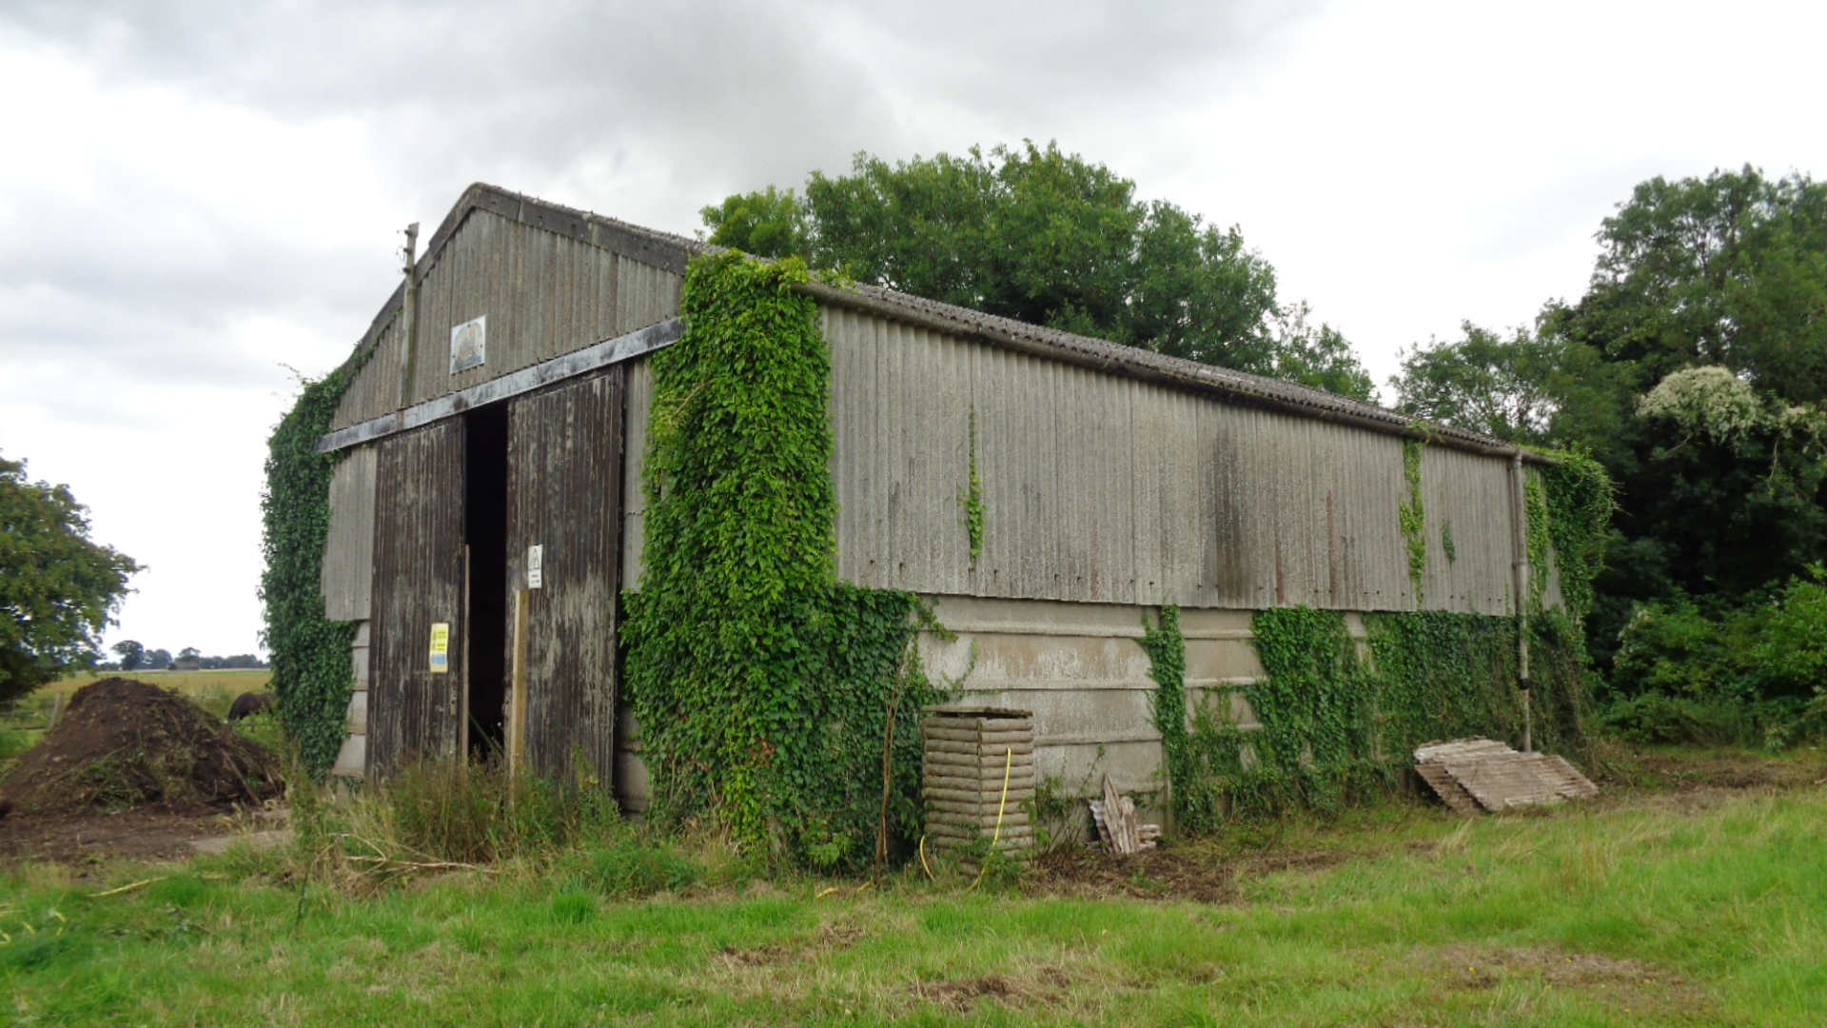

Ref: 4159-23

INTRODUCTION

We act on behalf of S E King Building Contractors Ltd in respect of the prior determination request made to South Holland District Council in relation to the potential change of use of an agricultural building at Maze Farm, Hospital Drove, Long Sutton, PE12 9EN to a residential dwelling.

Planning Permission is not deemed necessary for the proposed development on the basis that the proposal conforms with the provisions set out in the Town & Country Planning (General Permitted Development) (England) Order 2015.

PLANNING POLICY BACKGROUND

In the 2013 Budget Statement the Government announced its intention to consult on allowing further flexibilities between use classes to support the change of use. Building on the changes introduced in May 2013, a consultation was undertaken on ‘greater flexibilities for change of use’ and this included options for amending the Town and Country Planning (General Permitted Development) Order 1995 (as amended) to grant permitted development rights for various situations including rights to assist change of use and the associated physical works from existing buildings used for agricultural purposes to residential use (C3). This has now been consolidated within the Town and Country Planning (General Permitted Development) (Order) 2015.

The proposals were put forward to further enhance the Governments key objective to supporting economic growth. The proposals strongly support key Government priorities for making better use of buildings, supporting the high street and rural communities and providing new housing.

March 2012 saw the publication of the Governments National Planning Policy Framework (NPPF). This document replaces all Planning Policy Statements. The document states that there is a presumption in favour of sustainable development.

Given the Permitted Development Rights which have come into effect on the 6th April 2014, the Government clearly believe that the change of use of agricultural buildings to dwellings is in line with the NPPF and therefore the development it allows is sustainable. The changes allowed under the permitted development will make a strong contribution towards the provision of new homes, reducing some of the pressure for new green field development and allowing under utilised buildings to be brought back into productive use.

Planning Permission is not deemed necessary on the basis that the proposal conforms to the provisions set out in the Town and Country Planning (General Permitted Development) (England) Order 2015. Class Q allows for development consisting of:
- A change of use of a building and any land within its curtilage from a use as an agricultural building to a use falling within Class C3 (dwelling houses) of the Schedule to the Use Classes Order; and
- Building operations reasonably necessary to convert the building referred to in paragraph (a) to a use falling within Class C3 (dwelling houses) of the schedule.

The new permitted development provisions do not differentiate between the age, type or condition of any buildings which might be suitable for conversion.

The development will not be permitted if:-
- The site was not used solely fore an agricultural use a part of an established agricultural unit-
- On 20th March 2013, or
- In the case of a building which was in use before that date but was not in use on that date, when it was last in use, or
- In the case of a site which was in use after 20th March 2013, for a period of at least 10 years before the date development under Class Q begins;
- The cumulative floor space of the existing building or buildings changing use under Class Q within and established agricultural unit exceeds 450 square metres;
- The cumulative number of separate dwellinghouses developed under Class Q within an established agricultural unit exceeds 3;
- The site is occupied under an agricultural tenancy, unless the express consent of both the landlord and the tenant has been obtained;
- Less than 1 year before the date development begins-
- An agricultural tenancy over the site has been terminated, and
- The termination was for the purpose of carrying out development under Class Q, unless both the landlord and the tenant have agreed in writing that the site is no longer required for agricultural use;
- Development under Class A(a) or Class B(a) of Part 6 of this schedule (agricultural buildings and operations) has been carried out on the established agricultural unit-
- Since 20th March 2013; or
- Where development under Class Q begins after 20th March 2023, during the period which is 10 years before the date development under Class Q begins;
- The development would result in external dimensions of the building extending beyond the external dimensions of the existing building at any given point;
- The development under Class Q (together with any previous development under Class Q) would result in a building or buildings having more than 450 square metres of floor space having u use falling within Class C3 (dwellinghouses) of the Schedule to the Use Classes Order;
- The development under Class Q(b) would consist of building operations other than-
(i) the installation or replacement of-
(aa) windows, doors roofs, or exterior walls, or
(bb) water, drainage, electricity, gas or other services, to the extent reasonably necessary for the building to function as a dwelling house; and
(ii) Partial demolition to the extent reasonably necessary to carry out building operations allowed by Paragraph Q.1 (i)(i);
- The site is on article 2(3) land;
- The site is, or forms part of-
- A site of special scientific interest;
- A safety hazard area;
- A military explosives storage area;
- The site is, or contains, a scheduled monument; or
- The building is a listed building.
Conditions
Q.2 – (1) Where the development proposed is developed under Class Q(a) together with development under Class Q(b), development is permitted subject to the condition that before beginning the development, the developer must apply to the local planning authority for a determination as to whether the prior approval of the authority will be required as to-
(a) transport and highways impacts of the development,
(b) noise impacts of the development,
(c) contamination risks on the site,
(d) flooding risks on the site,
(e) whether the location or siting of the building makes it otherwise impractical or undesirable for the building to change from agricultural use to a use falling within Class C3 (dwellinghouses) of the Schedule to the Use Classes Order, and
(f) the design or external appearance of the building,
And the provisions of paragraph W (prior approval) of this Part apply in relation to that application.
(2) Where the development proposed is development under Class Q (a) only, development is permitted subject to the condition that before beginning the development, the developer must apply to the local planning authority for a determination as to whether the prior approval of the authority will be required as to the items referred to in sub-paragraphs (1)(a) to (e ) and the provisions of paragraph W (prior approval) of this Part apply in relation to that application.
(3) Development under Class Q is permitted subject to the Condition that development under Class Q (a), and under Class Q(b), if any, must be completed within a period of 3 years starting with the prior approval date.

THE SITE & BUILDING

The proposal relates to the change of use of an existing agricultural building and the land within its curtilage into a single dwelling house.

The agricultural barn and is land which has been occupied for the purposes of agricultural on or before the 20th March 2013.

The following criteria is satisfied:-
- The building is not on article 2(3) land
- The site was used for agricultural/horticultural purposes prior to 20th March 2013
- The site is not occupied under an agricultural tenancy, nor has one been terminated within the last 12 months
- The site does not form part of a safety hazard area or military explosives storage area
- The building is not listed or a scheduled monument
- No development utilising permitted rights have been undertaken on the unit/holding since 20th March 2013

The footprint of the building to be utilised for the change of use to a dwelling amounts to 465m2.

PRIOR DETERMINATION – CLASS Q(a)

In accordance with the Order, it is requested that a determination as to whether the prior approval of the LPA is required for the Class Q(a) development in this instance with regard to:-
- Transport – highways impact of the development
- Noise – impacts of the development on neighbours
- Contamination – a contamination report may be required
- Flood risks – a site specific flood risk assessment will not be required; the proposal is to raise the finished floor level 300mm above existing floor level
- Location & siting – it is impractical or undesirable for to change for agricultural/horticultural use to a use falling within Class 3 (dwelling houses) of the Schedule to the Use Class Order

TRANSPORT

The site is situated to the end of Hospital Drove and is sited within a range of barns which the smaller ones are becoming redundant in the agricultural world.

NOISE

There have never been any noise issues with existing residential properties in the area.

CONTAMINATION

A contamination assessment report may be required due to it’s agricultural use.

FLOOD RISK

The site lays within Flood Zone 3, a site-specific Flood Risk Assessment is attached with the application. This conversion will not risk any flooding elsewhere.

LOCATION & SITING

The site is accessed off the end of Hospital Drove and is surrounded by farmland and open views. The main barn views will be to the north, east and south. To the West of the site is a small farm with a liner development of dwellings.

CONCLUSION

It is deemed that the proposal for the change of use of the building should be considered permitted development, under the legislation in 2014 and now under Class Q of the General Permitted Development Order 2015.

The proposed change of use will not lead to any detrimental adverse impacts on traffic, noise, flood risk or contamination and the siting and location are deemed acceptable for the proposed use.

The residential conversion scheme can easily be incorporated into the existing fabric with new walls and roofing sheets added within the existing framework using allowances under the GPDO. The building is part of the Atcost concrete frame system and is suitable for conversion.

EXTERNAL MATERIALS

Walls – Larch vertical cladding
Roof – Zinc standing seam
Windows & Doors – Grey aluminium
Rainwater goods – Black metal

APPLICATION PLANS

4159-23-02 – Existing floor plans and elevations
4159-23-03A – Proposed floor plans and elevations
4159-23-04 – Site and location plans

S L Darlow
October 2022

