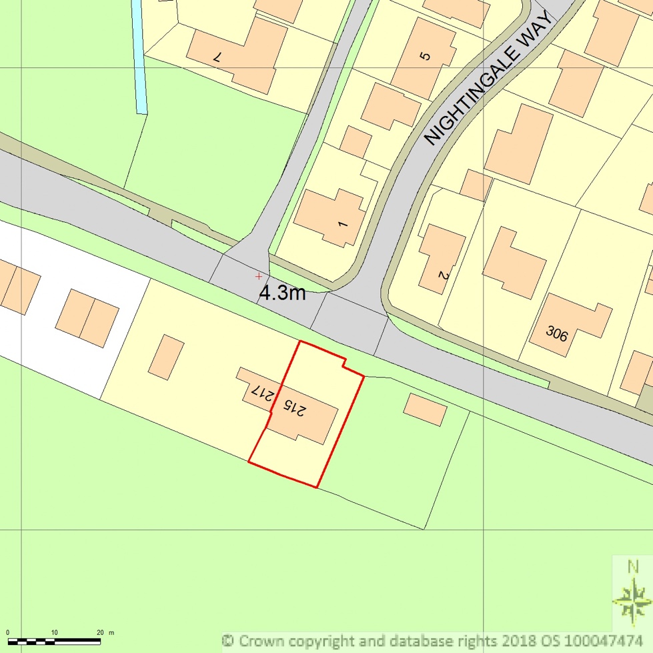
SITE LOCATION PLAN
AREA 2 HA
SCALE 1:1250 on A4
CENTRE COORDINATES: 546666, 321744



Supplied by Streetwise Maps Ltd
www.streetwise.net
Licence No: 100047474
02/11/2018 19:30

