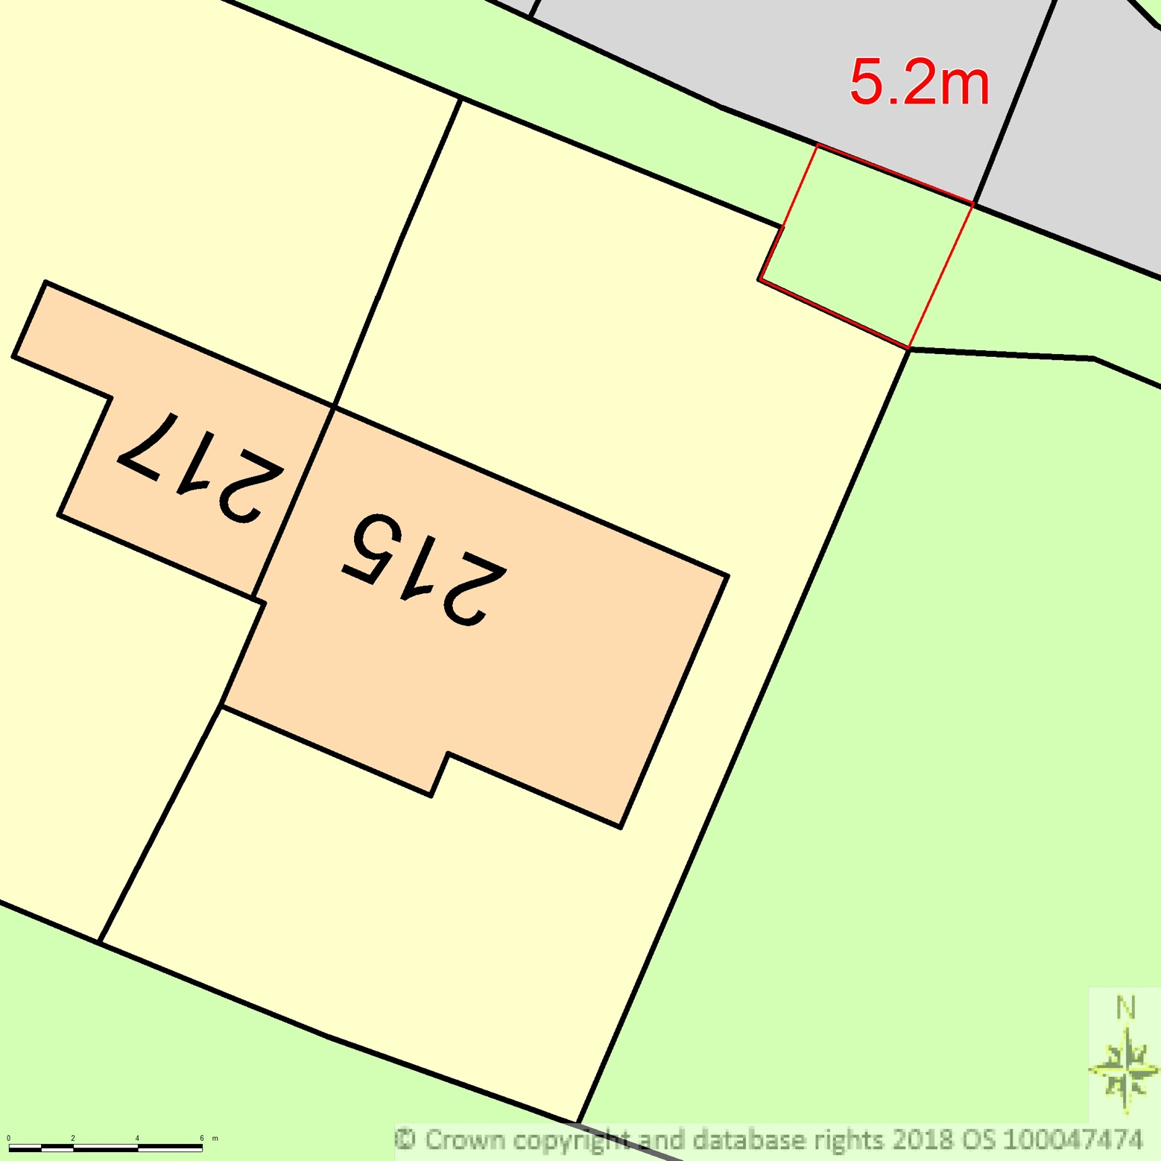
BLOCK/SITE PLAN
AREA 36m x 36m
SCALE 1:200 on A4
CENTRE COORDINATES: 546664, 321726



Supplied by Streetwise Maps Ltd
www.streetwise.net
Licence No: 100047474
02/11/2018 19:29:17

