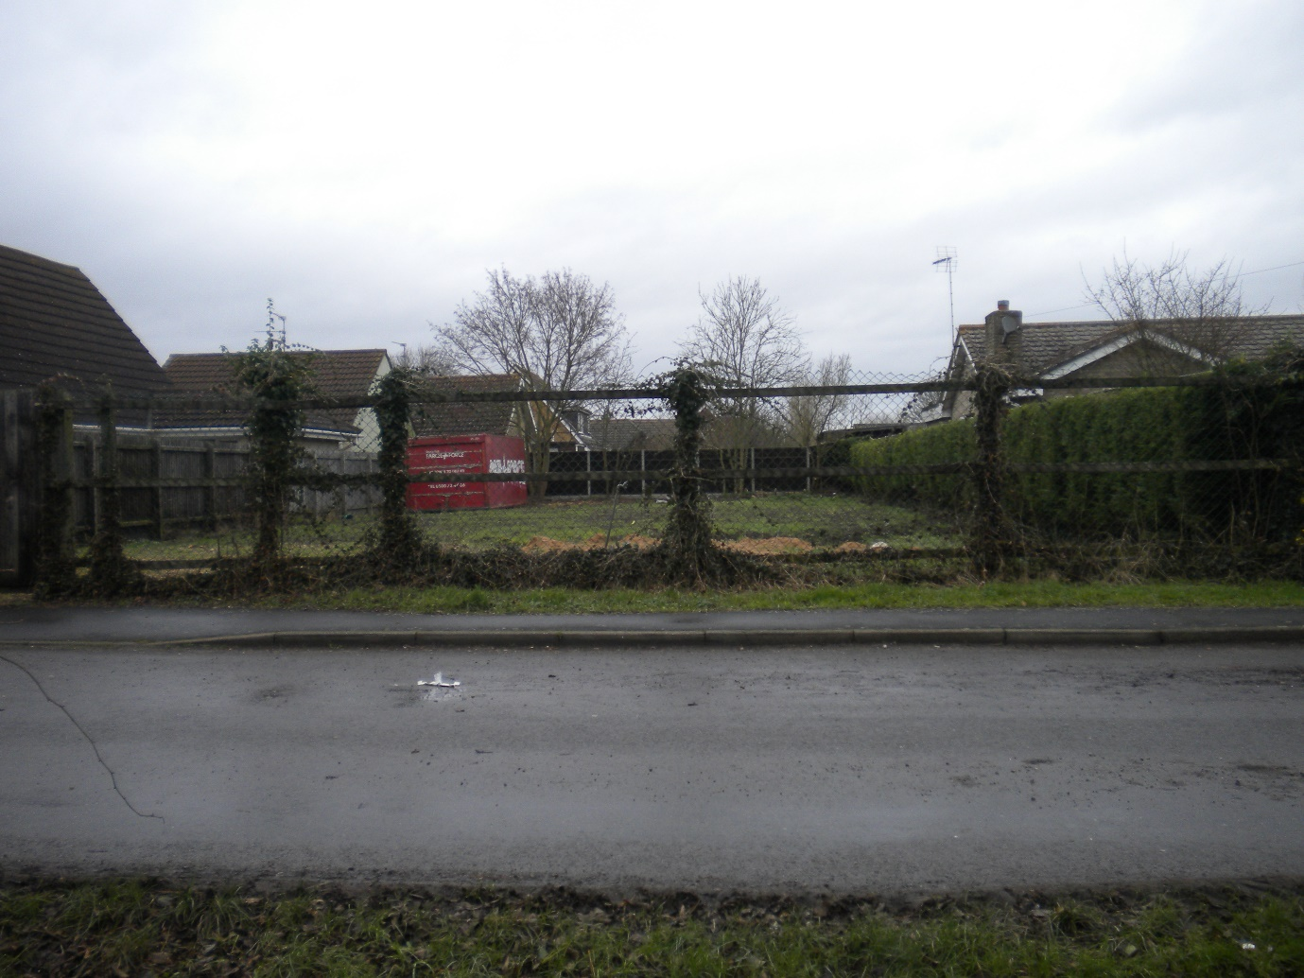

FLOOD RISK ASSESSMENT
FOR
PROPOSED RESIDENTIAL DEVELOPMENT
AT
3 CROSS ROAD
SUTTON ST EDMUND
LINCOLNSHIRE
PE12 0LS

FOR MR J WHITWELL.
1 DEVELOPMENT DESCRIPTION AND LOCATION.
1a Type of development and Location
The proposal is a Full Planning Application for Residential Development consisting of one new dwelling.
The site is located at 3 Cross Road Sutton St Edmund Lincolnshire PE12 0LS
1b Vulnerability Classification
The development for a Residential development falls within Zone 2 of both the Environment Agency and South Holland District Councils Flood Maps.
1c Local Development Documents
The proposal is consistent with the relevant aspects of the Local Development Plan.
1d Sequential Test/Exception Test
The site is 0.051 hectares and is for a Single Dwelling.
In terms of the sequential test there is no other similar land in the vicinity in the ownership of the applicant for the purposes of the test there is no other suitable land, or any alternative land that is at less risk in the immediate locality.

2 DEFINITION OF THE FLOOD HAZARD.
2a Sources of flooding that could affect the site.
The primary possible source of flooding of the site would be either from rivers or the sea, if there were no flood defences. This area could be flooded:
- from the sea by a flood that has a 0.5 per cent (1 in 200) or greater chance of happening each year;
- or from a river by a flood that has a 1 per cent (1 in 100) or greater chance of happening each year.
Extreme rainfall could be another possible cause of flooding.
2b Identified flooding sources – how they might affect the site.
Fluvial flow and overtopping of the embankments would not inundate the site rapidly as the site is located further away from the source than much of the more prone areas closer to the sea or river. Any flooding scenario would be likely to be signalled well in advance with flood warnings, weather reports and local observations as to water levels within the river.
Extreme rainfall on the site should not have a major effect, as the site stands alone, has well drained surfaces.
2c Existing surface water arrangements.
The adjacent and existing properties are served by soakaways.

3 PROBABILITY
3a Flood Zone
The site is within Flood Zone 2
3b Existing Surface water rates and volumes of run off generated by the site.
The site will not generate any significant additional surface water runoff.

4 CLIMATE CHANGE
4a How is flood risk at the site likely to be affected by climate change
The site may be at risk if sea levels and river flows increase with climate change.
The site may be at increased risk if rainfall increases with climate change.
In mitigation the proposed dwellings can be built in accordance with e the latest Environment Agency recommendations thus reducing any risk to a minimal level.

5 DETAILED DEVELOPMENT PROPOSALS.
5a Details of the proposed development
Please see drawing Numbered 1554-01
Application for Full Planning Approval for Residential Development.

6 FLOOD RISK MANAGEMENT MEASURES
6a How will the site be protected from flooding, including the potential impacts of climate change over the developments lifetime.
The site sits some distance away from any rivers being mid-way between the Welland and the Nene on which the banks have been strengthened and raised and there are large areas of flood plain adjacent to the river.
The site sits some distance away from the sea and the existing defensive banks are in good condition. They were not breached in the 2013 tidal surge.
The proposed new residence will have its floor level raised to 300mm above that of the surrounding ground levels.
A place of Refuge will be constructed within the Roof Void
The applicant will sign up to the local `Flood Early Warning scheme`.
The building will incorporate flood resilient construction.

7 OFF SITE IMPACTS
7a How will you ensure that your proposed development and measures to protect your site from flooding will not increase flood risk elsewhere.
By observation they will not because there will be minimal additional storm water runoff.
7b How will you prevent run-off from the completed development causing an impact elsewhere.
Because the development is for the change of use of an existing range of barns and here will be no increase in storm water runoff and new more efficient soakaways will be constructed as part of the development.

