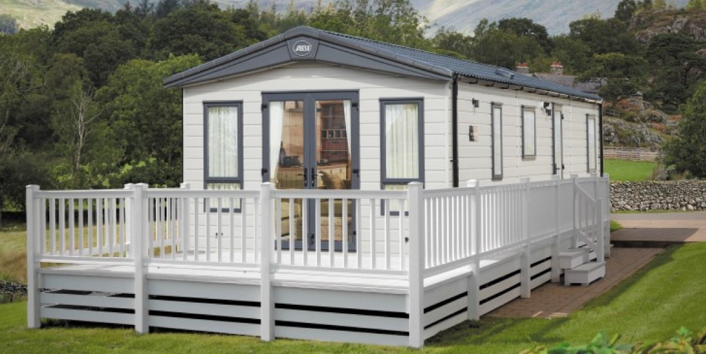

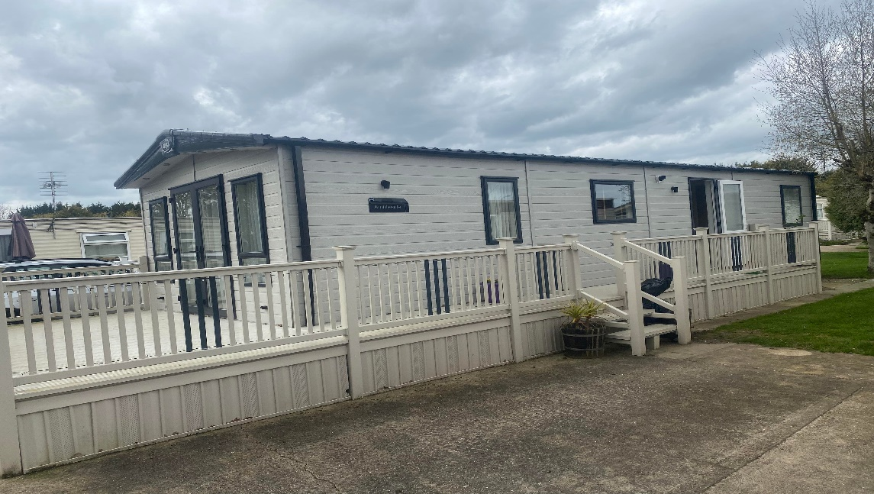

2018 ABI HOLIDAY HOMES AMBLESIDE PREMIER 41 X 14 2 BED
- Make ABI HOLIDAY HOMES
- Range AMBLESIDE PREMIER
- Model 41 X 14 2 BED
- Year 2018
- New Or Used New
- Size 41 X 14 mm
- Bedrooms 2 mm
- Berth 2

