Flood Risk Assessment

Site attached to 2 Church Lane, Tydd St Mary, Wisbech PE13 5QJ
Proposal: Erection and support for 40 foot x 14 foot static caravan; services (waste, electric and water) to be run from 2 Church Lane, Tydd St Mary, Wisbech PE13 5QJ to site
Purpose: To provide full-time care for elderly family member;
Reason: This site was chosen by Lauri Di-Giulio and Benjamin Di-Giulio, joint property owners of 2 Church Lane, Tydd St Mary, Wisbech PE13 5QJ due to:
- the close proximity to the family home
- inadequate space and facilities in the main home to live with family
- Lauri Di-Giulio is the sole carer for elderly grandmother
- vacant and unused land in order to provide a site for static caravan
- out of view from neighbouring homes
- shorter distance to run services
- easy access and manoeuvrability for transporter of the static caravan from the high street
- opportunities to increase biodiversity whilst managing flood risk
Site Coordinates:
Grid Reference | 52.745297, 0.139115
grid | TF4449818551
eastnorth | 544498 318551
utm | 31 N 306904 5847773
geohash | u12h51vr7r
road | Church Lane
place | Tydd St Mary
postcode | PE13 5QJ

The following evidence supports the following objectives:
- The proposed development is unlikely to be affected by current or future flooding from any source.
- The proposed development will not increase flood risk elsewhere.
- The appropriate measures will be taken to deal with any effects or risks of flooding, including climate change allowances.
- The sequential test is not appropriate. This is due to no other sites available on owned property for a separate dwelling in close proximity to the family home.

The following proposed site lies within land in flood zone 2. This is defined with a medium probability of flooding from rivers and the sea.

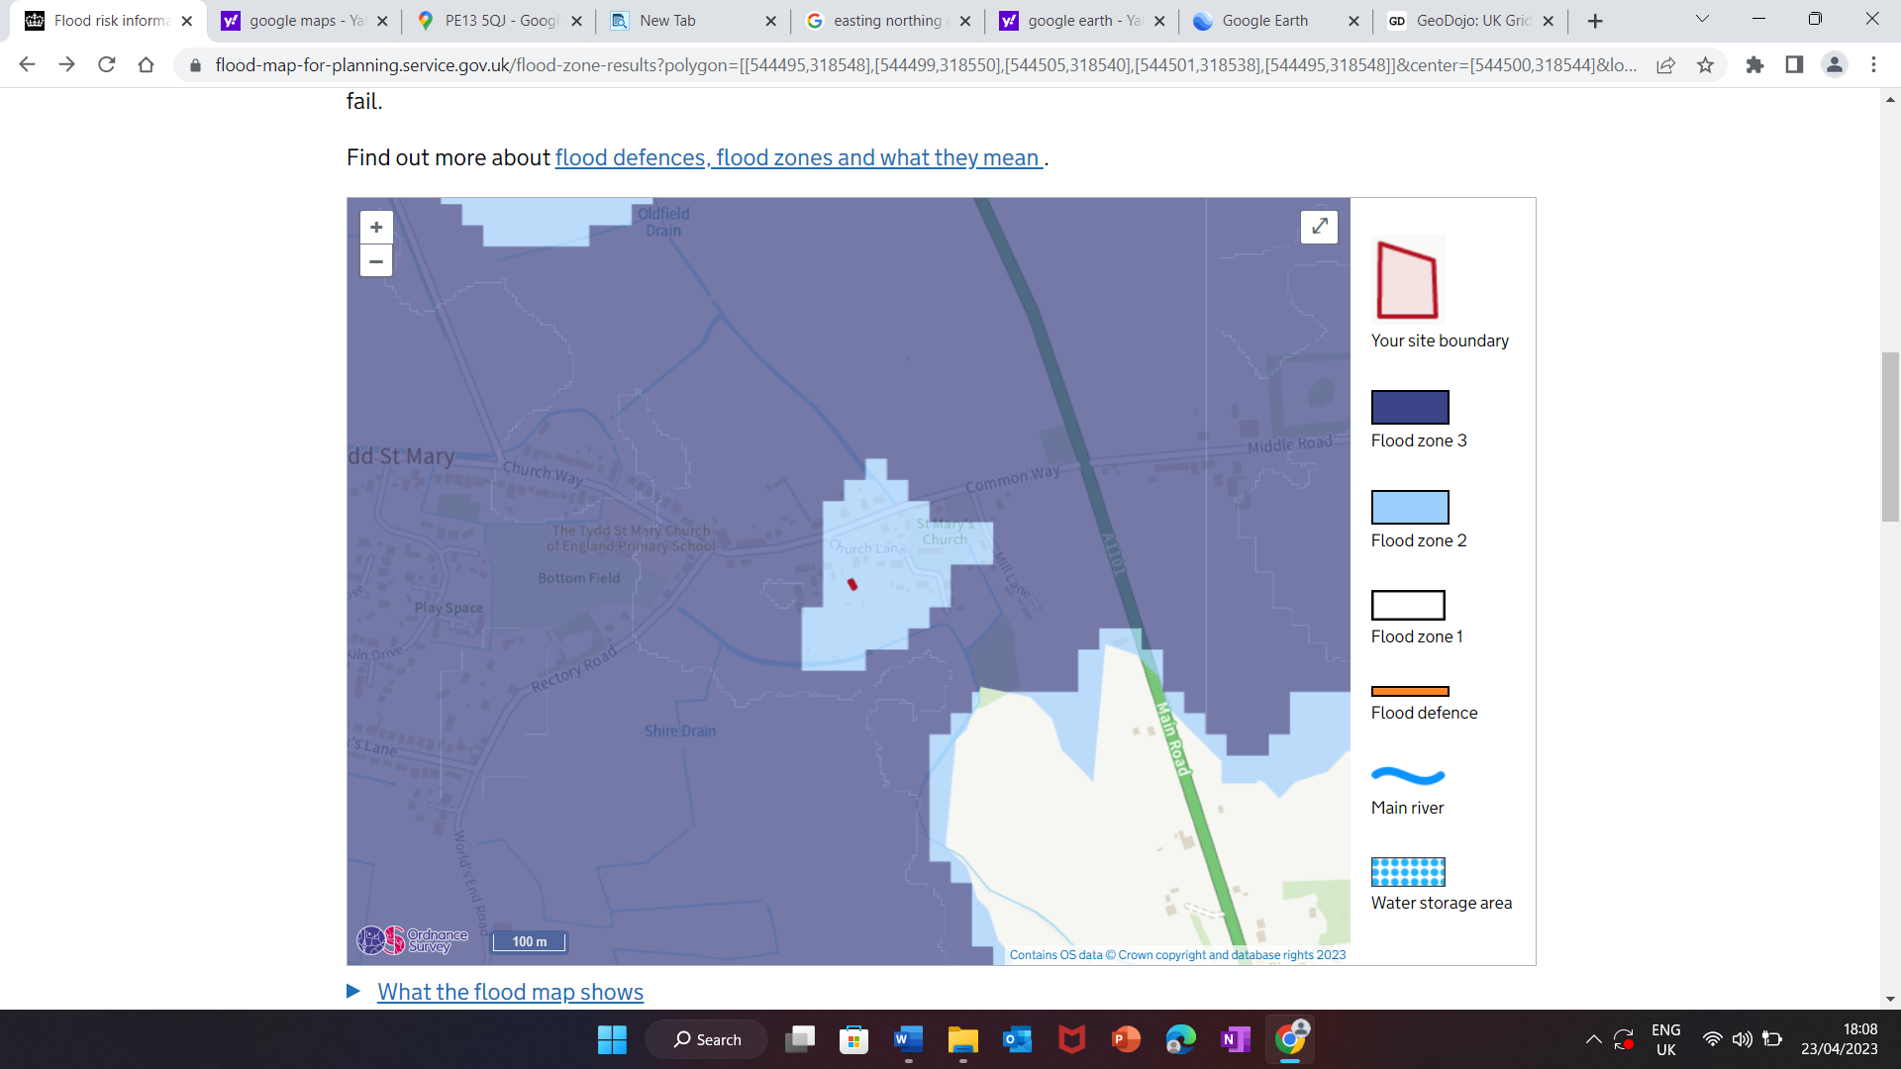

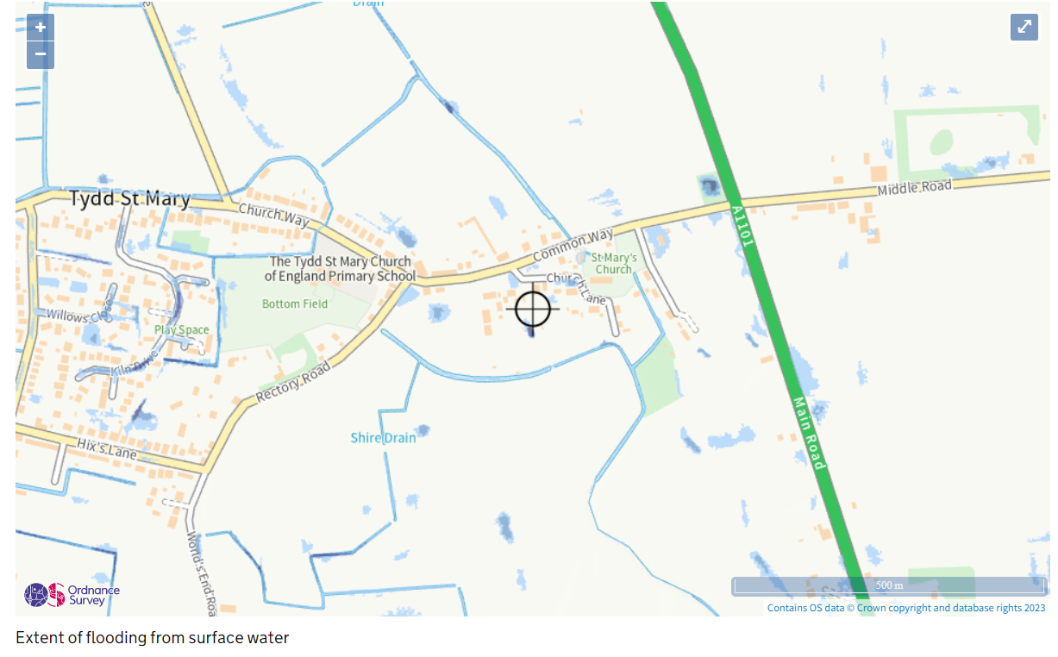

Allowance for climate change:
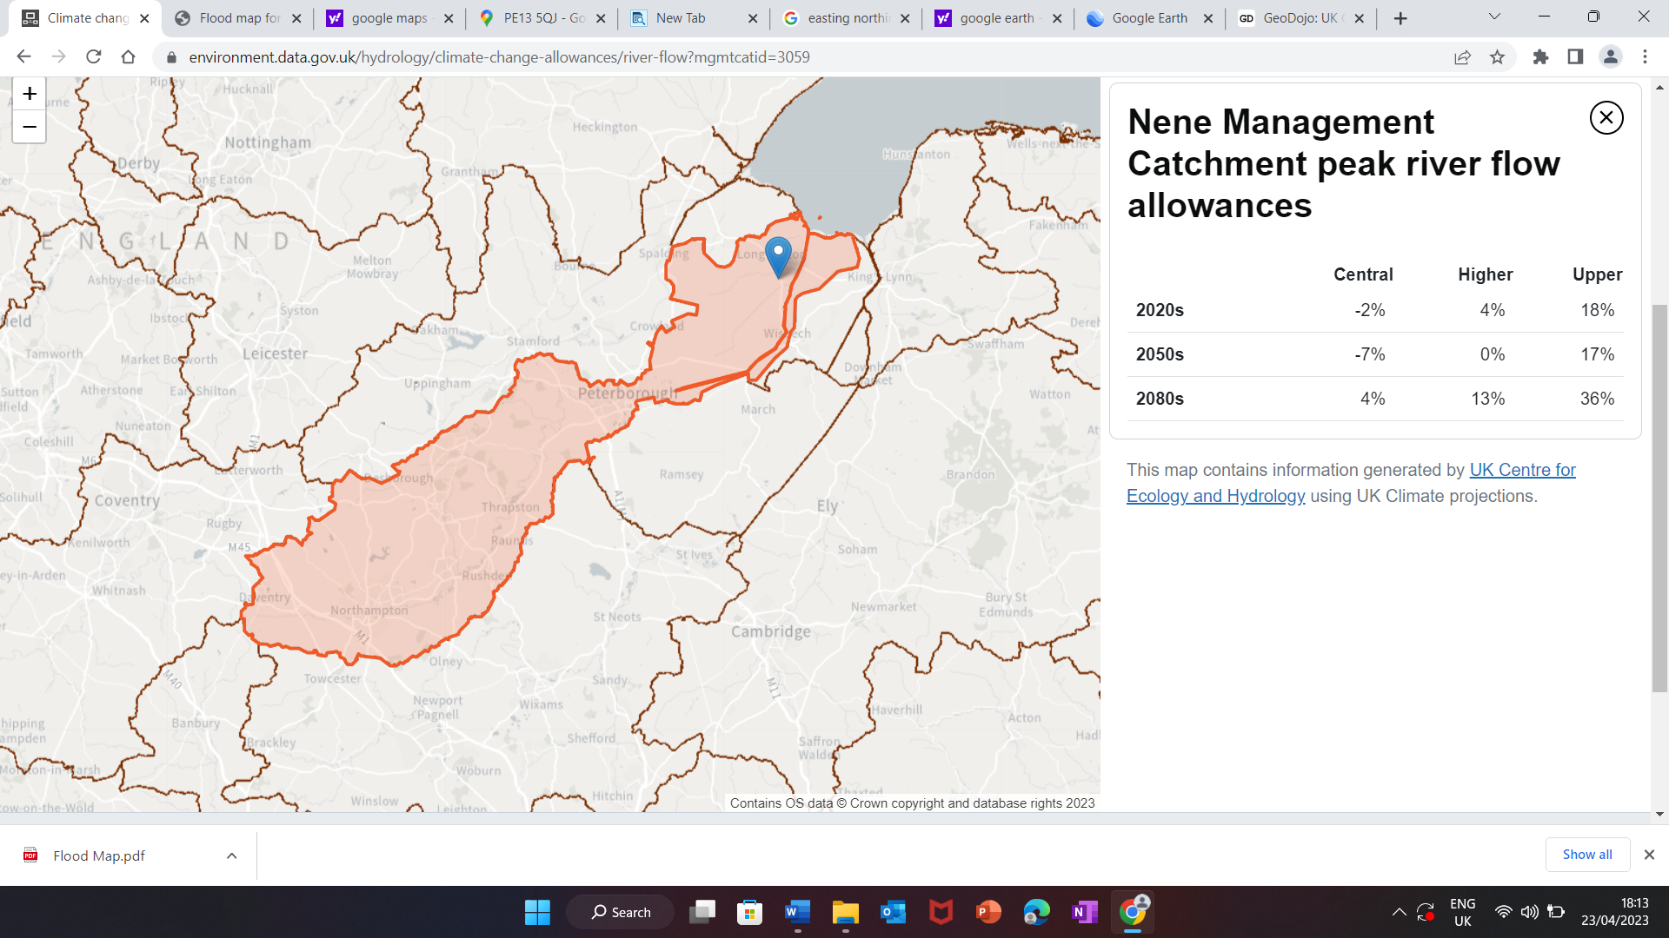

The Environment Agency’s Flood Risk Summary for the area around:

2, CHURCH LANE, TYDD ST. MARY, WISBECH, PE13 5QJ

Flood Risk from Surface Water

Very low risk: This area has a chance of flooding of less that 0.1% each year.
Lead local flood authorities (LLFA) are responsible for managing the flood risk from surface water.
Your LLFA is Lincolnshire council.

Rivers and the sea
Low risk
Low risk means that this area has a chance of flooding of between 0.1% and 1% each year. This takes into account flood defences already in place.
The Environment Agency is responsible for managing the flood risk from rivers and the sea.

Reservoirs
Flooding from reservoirs is unlikely in this area

Groundwater
Flooding from groundwater is unlikely in this area

Managing Flood Risk
In order to reduce flooding:
- Existing sheds around the proposed site will be dismantled and removed to provide more ground surface area for water absorption.
- Removal of existing outbuildings will offset the run off from the roof of the static caravan.
- To increase biodiversity and decrease flood risk, down pipe from guttering on static caravan will be positioned for runoff from roof to be directed into existing pond.
- A soak away installed for any overflow making allowances for extreme conditions due to climate change.
- Native hedgerows to be planted around perimeters of overall property to aid water absorption.

