Tree Report, Hedgerow Tydd St Mary, 15 May 2024

Introduction
This report was commissioned for Proctor Bothers Ltd and concerns a line of trees growing between a field and a garden on the edge of the village of Tydd St Mary in south Lincolnshire.
Some or all the trees are thought to be subject of tree preservation orders.

Findings
Ten trees were recorded growing along the southern side of a ditch, their locations are shown on the map below and their details and management recommendations are recorded in Table 1 below.
Eight of the trees were hybrid black poplars, all in the latter stages of decline, one was dead. The two remaining trees were ash, also in decline but less so and much smaller than the poplars.
The trees lean to the south over an agricultural field, to their north is a large garden. The owners of the field are erecting a rabbit fence along the boundary to protect the crops but the poplars have been dropping large branches that would damage the fence so the fence cannot be completed at present.
All the poplar trees have lost major limbs, their upper crowns have substantially died back, and their stems are extensively decayed, they have life expectancies of less than 10 years.
The trees do not significantly overhang the garden to the north and there is a sprawling Lonicera hedge that prevents the area under the trees from being used but also hides a rabbit warren.
The trees are in a relatively low-risk location.
Most of the poplar trees have large cavities in their stems that were occupied at the time of inspection by jackdaw nests.

Recommendations
The poplar trees are all extensively decayed and in the process of collapse so have come to the end of their useful lives however the nesting birds in the trees are protected under the Wildlife and Countryside Act 1981. There is also the possibility of some of the cavities in the trees being used as bat roosts.
Tree T02 is dead and does not have obvious cavities so can be felled.
The remaining poplar trees could be felled once the bird nests have been abandoned, this will require TPO consent but given the poor condition of the trees this should be granted.
The westernmost poplar tree (T10) has lost its top at 10m and is relatively vigorous, if its remaining limbs are reduced to 4m to 5m from the stem it could be retained as wildlife habitat.
A survey for active bat roosts would be justified.
The ash trees have minor dieback but are worth retaining, tree T05 looks like an old pollard and has a large cavity and would benefit from having the two large limbs removed. Tree T09 requires no action.

Nigel Sardeson MICFor
21 May 2024

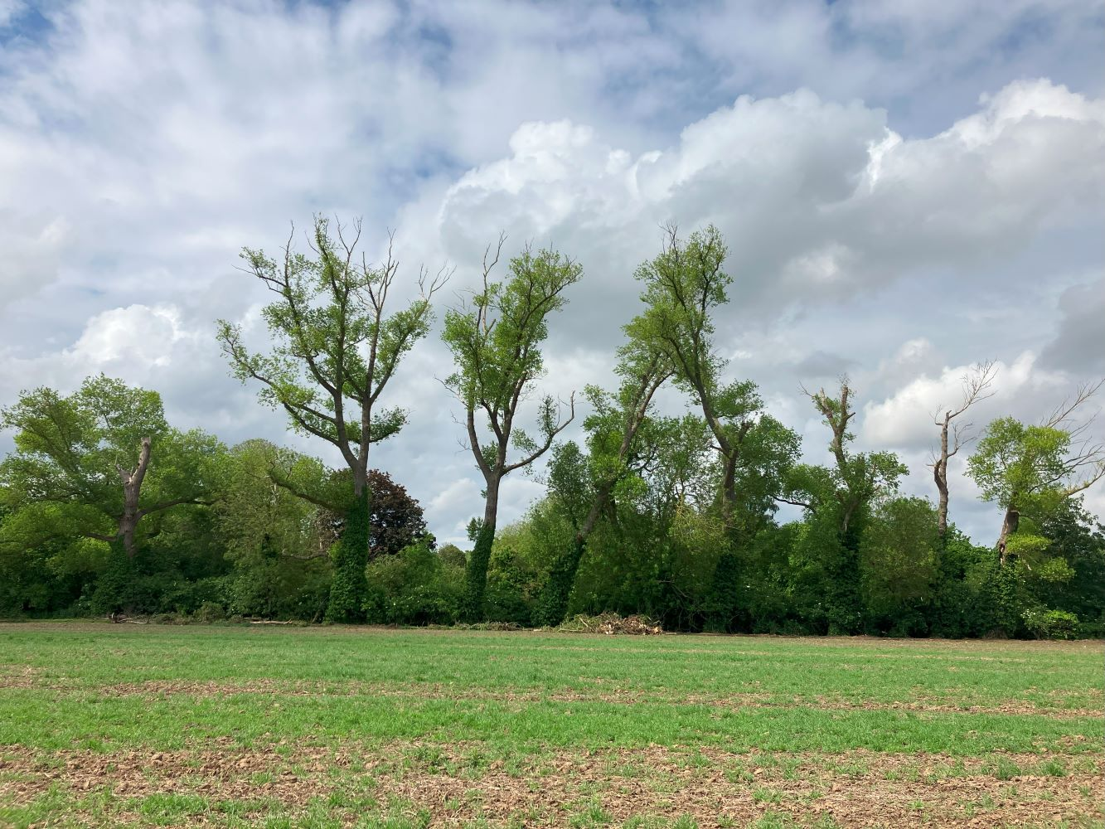
Trees T10 to T1 left to right from the south

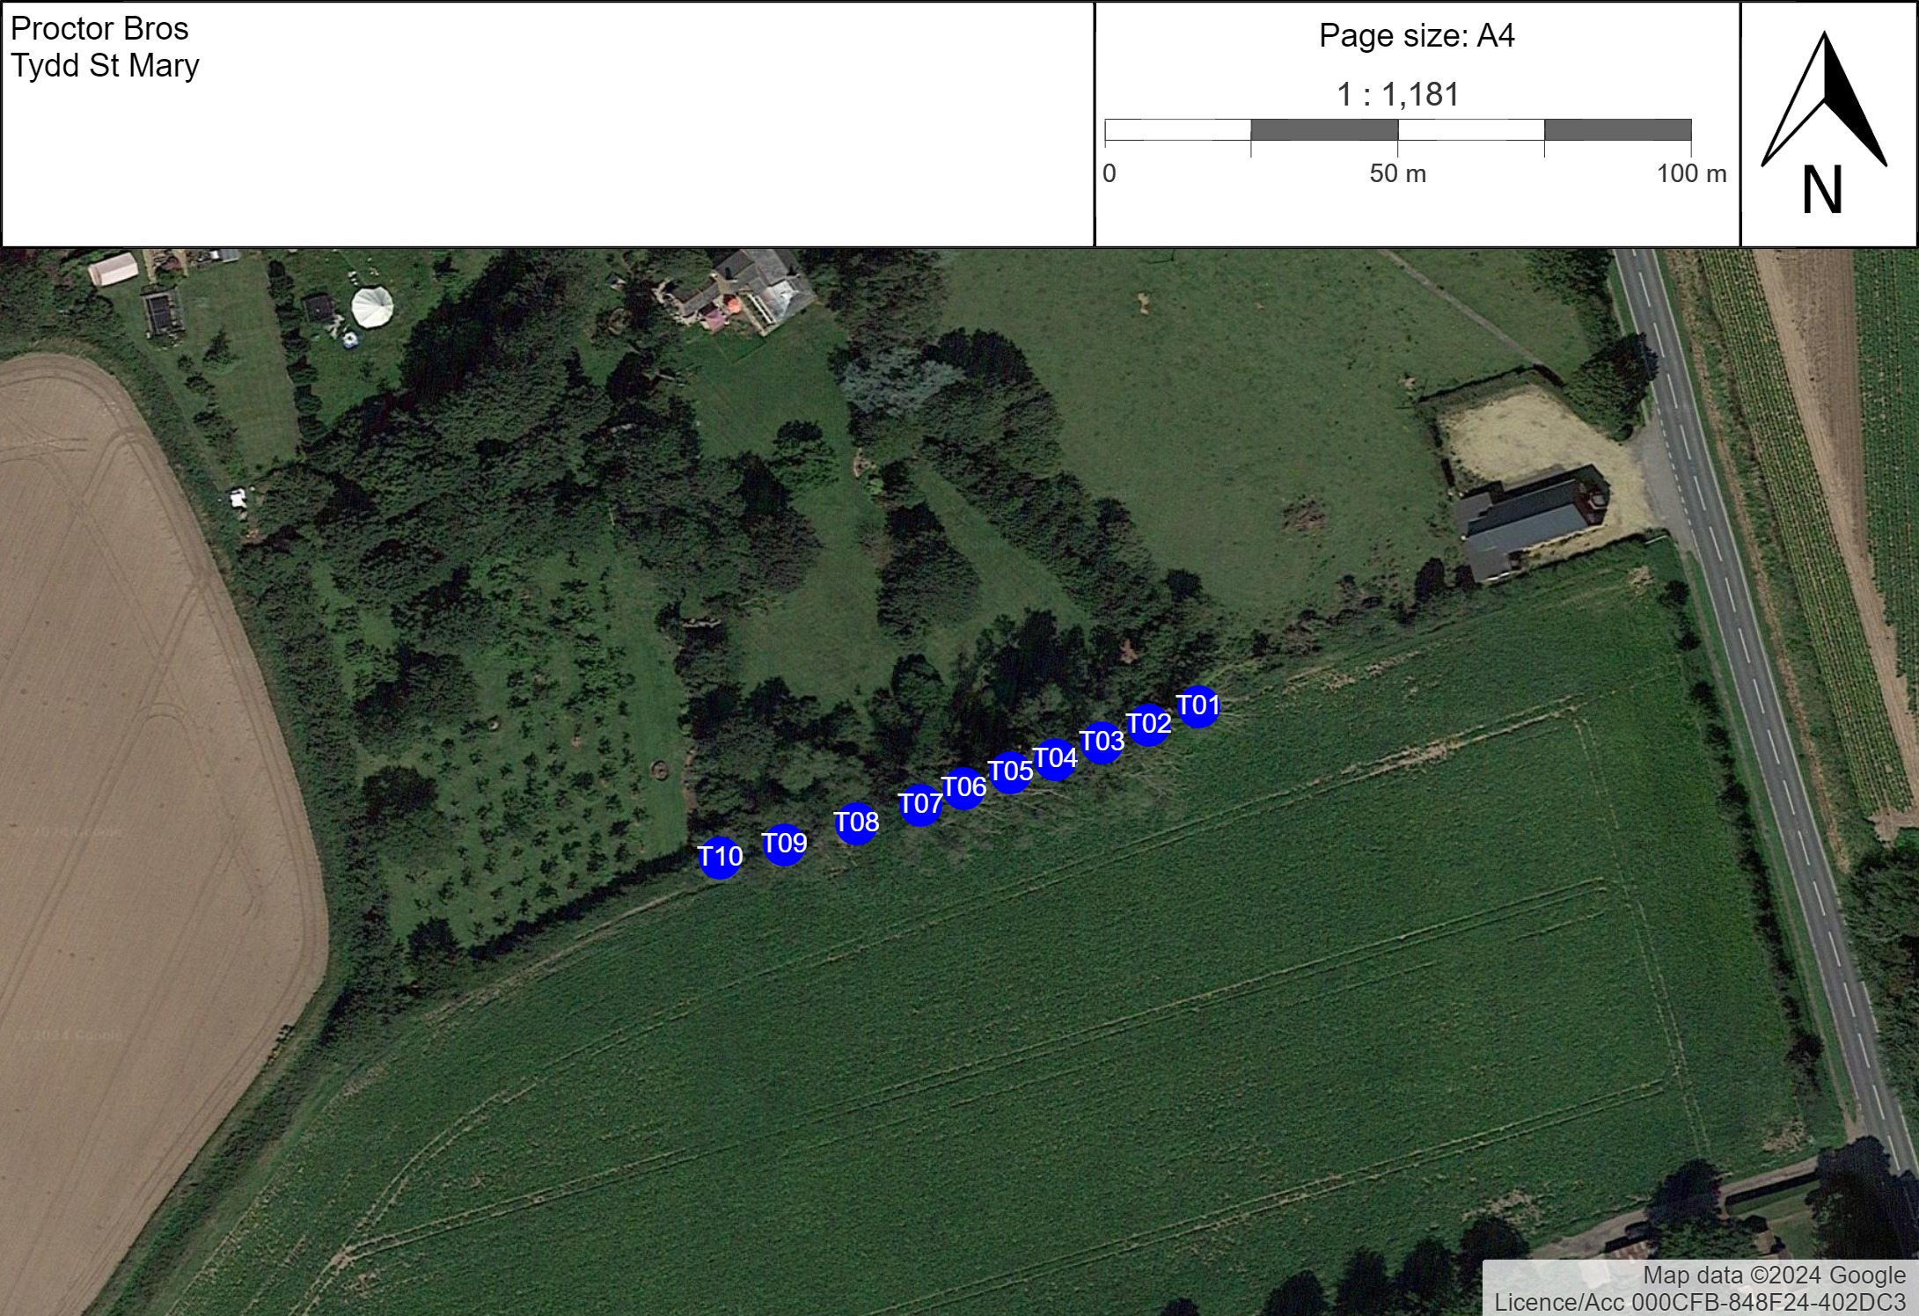

Table 1.
Ref. | Species | Measurements | Survey Notes | Recommendations
T01 | Black poplar  (Populus nigra) | Height (m): 16  DBH (cm): 90 | Advanced decline, dense ivy to 6m, stem and base hollow and decayed, lean to south, dead above 8m. Hollow stem occupied by bird nests | Fell after bird nesting season  (1 Year)
T02 | Black poplar  (Populus nigra) | Height (m): 16  DBH (cm): 70 | Dead, ivy to 7m, lost top | Fell  (1 Year)
T03 | Black poplar  (Populus nigra) | Height (m): 16  DBH (cm): 90 | Has lost all major limbs, ivy to 8m , decayed stem and base | Fell after bird nesting  (1 Year)
T04 | Black poplar  (Populus nigra) | Height (m): 25  DBH (cm): 90 | Has lost leading stem (50cm diameter) at 12m, hollow, decayed, probably occupied by nesting birds | Fell after bird nesting season  (1 Year)
T05 | Common ash  (Fraxinus excelsior) | Height (m): 14  DBH (cm): 60 | Forked at 2m, 10% dieback, old pollard, large cavity at 3m north-side | Could remove 2x larger limbs at 4m  (1 Year)
T06 | Black poplar  (Populus nigra) | Height (m): 25  DBH (cm): 80 | Lean to east over T5, ivy to 6m, has lost limbs, upper crown dying-back, large bracket fungus (Ganoderma type) on base, base and stem decayed. | Fell after bird nesting  (1 Year)
T07 | Black poplar  (Populus nigra) | Height (m): 25  DBH (cm): 100 | Ivy to 6m, upper crown dead, lost some limbs, large Ganoderma-type fungus on base | Fell after bird nesting  (1 Year)
T08 | Black poplar  (Populus nigra) | Height (m): 25  DBH (cm): 120 | Upper crown dead, ivy to 8m, decayed base, cavities in stem, appear occupied by nesting birds | Fell after bird nesting  (1 Year)
T09 | Common ash  (Fraxinus excelsior) | Height (m): 10  DBH (cm): 50 | Heavy ivy, 10% dieback, hollow | No action  (1 Year)
T10 | Black poplar  (Populus nigra) | Height (m): 13  DBH (cm): 120 | Lost crown above 10m (60cm diameter), decayed, hollow stem, occupied by bird nests. Relatively vigorous | Reduce branches to 4m-5m from stem  (1 Year)

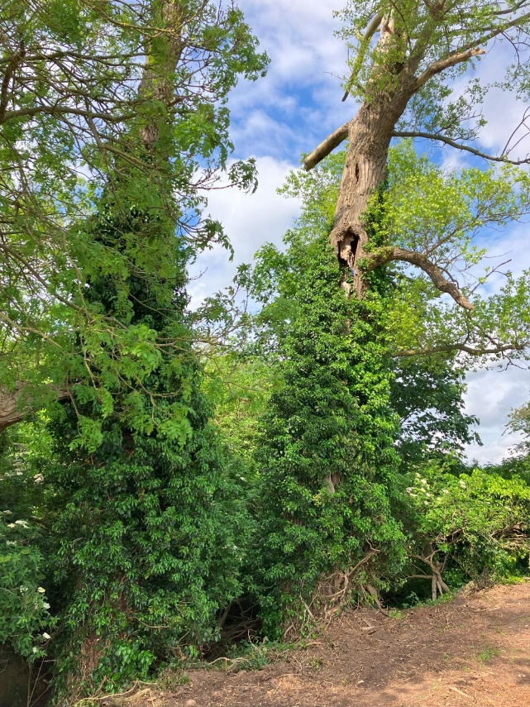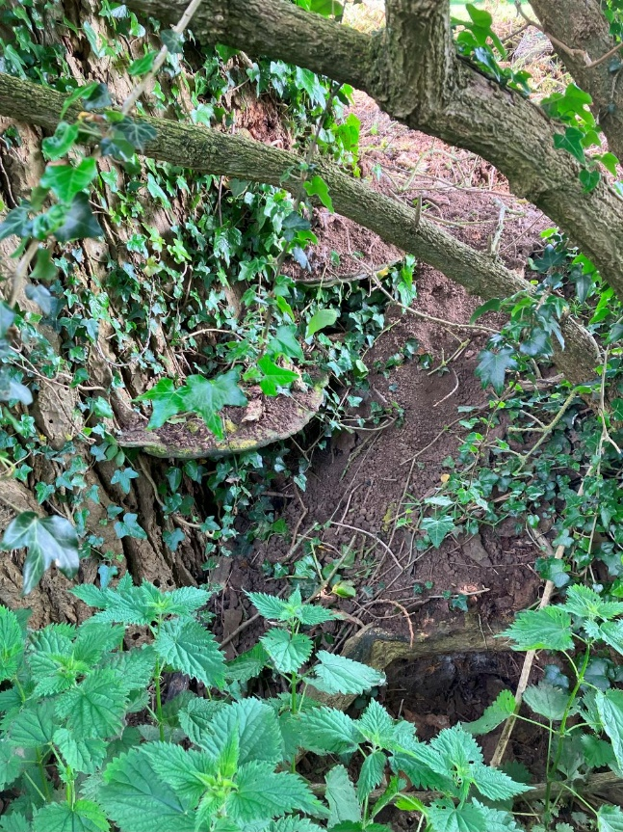
T02 and T01 showing cavities Fungi on base of T06

