

Tree Report

Mrs Shea
The Meadows,
Tydd St Mary
PE13 5QP

Ash Situated in the Side Garden

This tree is approximately 18 metres tall with a 6-metre canopy spread and a 900mm trunk diameter. The canopy looks in fair condition, with minor cavities on stem. However, there are signs of the tree suffering from inonotus brackets, this is a fungus that eats away at the heart wood of the tree and can make them prone to sudden limb failure. (Please see picture attached below)
Recommendations
Due to this we would recommend this tree is removed in its entirety. The client has informed us that the tree officer has been out and has also recommended removal.
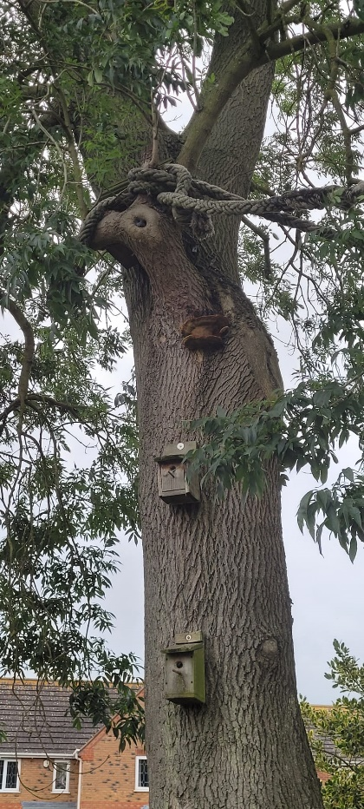

35 County Road, March PE15 8ND
Tel: 01354 656582 Mobile: 07926 431464

