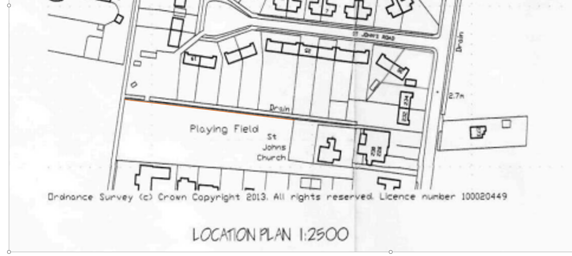
1 2 3
4 5

5
5
1- Climbing Frame
2 – Somersalt bars
3 – Slide
4 – Springers
5 - Trampoline
Ref PP-12951937 Playing Field Weston Hills 2024, Weston Parish Council – Location of new equipment

