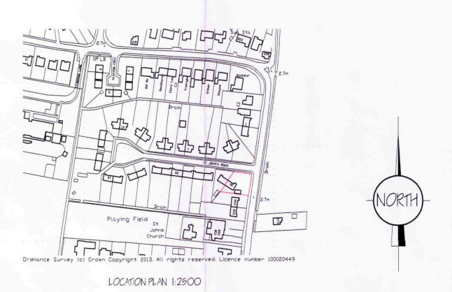
Ref PP-12951937 Playing Field Weston Hills 2024, Weston Parish Council – Location of new equipment in red boxed area of the map

