Weston Hills Playing Field
We have the COSHH assessments and safety data sheets for the RoadArt which will be submitted to
the District Surveyor for their approval.
Basketball Hoop
3 Bay Swings
Football Goal

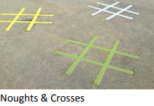
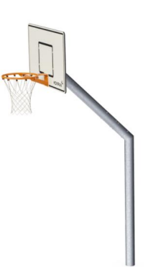
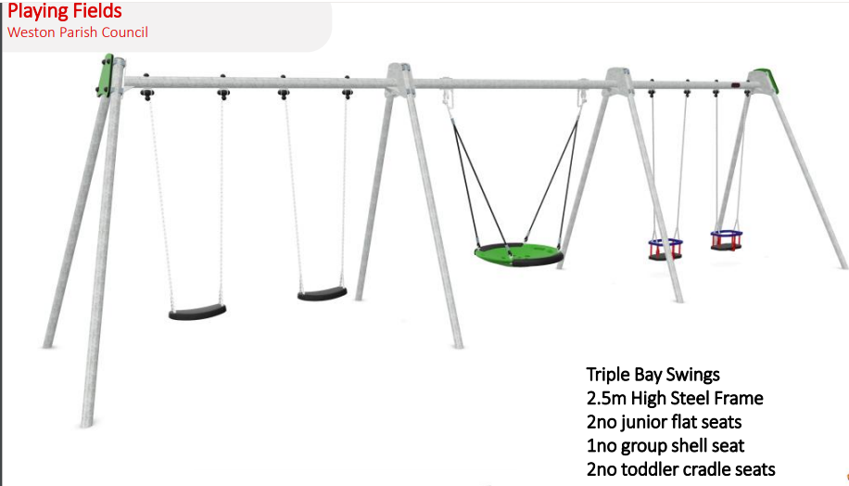
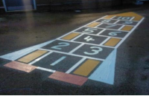
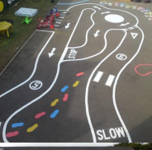
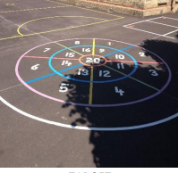
OXO
Rocket
Hopscotch
Target Game
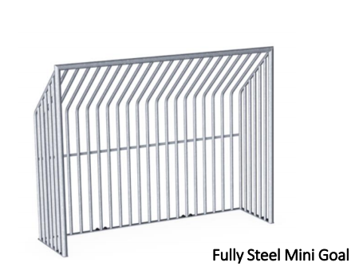
Cycle/scooter route
Basketball Hoop
Basket Ball D Markings
3 Bay Swings
Football Goal

