Consultation Response
H23-0313-25 - Land At Peartree Hill Road Whaplode Drove Spalding PE12 0SL
Provision of new poultry unit & associated works
Author: Chris De Ruyck, PhD, MNRM. Senior Ecologist, SELCP

Summary: I wish to submit a holding objection on this application due to the lack of ecological impact information submitted in relation to waste management, ammonia and nitrogen emissions, and the cumulative impacts on local wildlife sites and priority habitats in the area (details described below).
In addition, the authority cannot be confident that the development will achieve 10% BNG on-site as currently estimated because the proposed post-development habitat targets do not adequately mitigate against risks of failure. Upon amending the metric to reflect more achievable habitat targets, we predict that the development may need to secure up to 5.24 additional habitat area units (on-site or off-site) to achieve 10% BNG. These details will have to be finalized and approved by the authority pre-commencement.
Please note that a biodiversity gain plan and habitat management and monitoring would need to be submitted to the authority for approval pre-commencement. In addition, a S106 planning obligation would also be required to secure the on-site biodiversity provision and 10% net gain for the development in line with national guidelines due to the scale and complexity of on-site habitat creation.

Documents reviewed:
- Amended BNG Statutory Metric
- Baseline and post development maps
- Environmental statement_2
- Odour Impact Assessment
- Simple Calculation of Atmospheric Limits (SCAIL report)
- Assessment of Impact of Airborne Emissions of Particulate Matter

BNG Considerations:
The baseline BNG assessment is sufficiently rigorous and accurate, however, uncertainty remains about the feasibility of achieving and maintaining the proposed post-development grassland habitats and ditches in “good” condition. The statutory guidance is clear in advocating a precautionary approach to setting habitat targets and dealing with uncertainty and risk in the absence of supporting evidence. Therefore, the onus is on the applicants to justify their approach and provide evidence that the proposals will realistically achieve a measurable 10% increase in biodiversity. Otherwise, I advocate adopting a more cautious approach to on-site habitat provision as described below, which would necessitate securing a greater number of off-site area-habitat and watercourse units to achieve 10% BNG. In addition, we seek clarification regarding how the post-development watercourse/ditch habitats are scored in the metric (details below). In both cases, these details do not have to be confirmed until the applicant seeks to discharge the gain condition pre-commencement, however, I strongly advise that they are finalized as early as possible in the planning process to reduce uncertainty and avoid risks of delay.
Watercourse unit scoring clarification. - I do not believe that the current approach to scoring the baseline and post-development biodiversity value of the ditches accurately captures the expected changes in watercourse biodiversity. Currently, the riparian encroachment for the entire 1.03 km of ditches on-site is classified in the metric as minor/no-encroachment and the habitat condition is classed as moderate, while post-development the encroachment is classed as minor/minor and the habitat condition is classed as “good”, which results in an estimated net change of +3.15 watercourse units. However, the degree of riparian habitat encroachment appears identical between the baseline and post-development habitats except where the access road will be built in the north-east corner of the site. Therefore, I believe that nearly the entire extent of post-development watercourse should remain as “minor/no encroachment” other than the small section corresponding to the roadway, which should be classed as “major/major”. Changing this in the metric will reduce the number of biodiversity units required to achieve a10% gain; In addition, I believe it will be problematic to enhance the habitat condition of the entirety of the on-site ditches from moderate to good condition and maintain this over the 30 year BNG period, and therefore there is an unacceptably high risk of failure. Instead, the post-development habitat condition in the metric should remain classed as “moderate” condition unless further information is provided to demonstrate how this improvement will be achieved (e.g., what management actions will be used to improve which habitat condition criteria, where/when will these interventions occur, and what are the expected costs of this management over the 30 year period?). In the absence of these additional details, I believe the metric should be amended such that the post-development habitat is classed as “moderate”, and the applicant will need to secure a small number of off-site units to achieve the mandatory 10% gain. For example, I estimate that roughly 0.87 off-site watercourse units will be required if none of the ditches are improved to “good” condition.
Grassland habitat. - From the outset, I do not wish to undermine a project’s efforts to achieve grassland in a “good” target condition, however, I want to highlight to planning officers and developers the implications of accepting this management target in the metric assessment. Currently, the amended metric records the proposed post-development habitat targets as “modified grassland” in “good” condition, and I argue that this amended goal still does not adequately mitigate against the risk of failure. Therefore, I suggest that the post-development targets are amended to either “modified grassland” in “moderate” condition, or “other neutral grassland” in “poor” condition for the following reasons:
- There is some overlap in the structure and species composition of “modified grassland” in good condition and “other neutral grassland” in poor condition, and there is a corresponding overlap in the metric’s habitat-unit values between the conditions scores of these two habitats. For example, note the close similarity in scores between “moderate” condition modified grassland and “poor” condition neutral grassland in comparison to “good” condition modified grassland in the figure below. Most importantly, the number of condition criteria that must be passed for each target varies significantly. A “good” modified grassland habitat condition score requires 6-7 condition criteria to be met (each with its own probability of failure and including > 6 species /sqm) in comparison to a “moderate” condition score that requires 4-5 criteria to be met, or “poor” condition requiring 3 criteria to be met, and thus there is a greater cumulative risk of the habitats failing to demonstrate a “good” condition compared to “moderate” or “poor” condition for any given year.
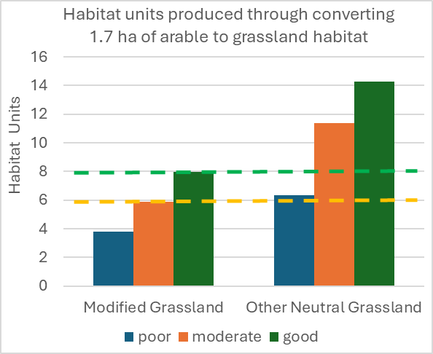
Figure 1. Statutory metric unit-score comparison (left axis) of modified grassland in moderate or good condition compared to other neutral grassland in poor condition.
- As previously noted, these grassland areas are immediately adjacent to the barns and therefore will be exposed to high concentrations of atmospheric ammonia, nitrous oxides, and nitrogen deposition, which will likely reduce the likelihood of passing some of the required habitat condition criteria. Ammonia and nitrous oxides act as environmental pollutants that damage broad-leaf plant cells, inhibit growth, and make plants more vulnerable to stressors such as drought, pathogens or physical damage. In addition, they contribute to terrestrial eutrophication whereby fast-growing grasses adapted to high nutrient/Nitrogen levels will outcompete the large majority of herbaceous grassland plants adapted to low-nutrient conditions, thereby cumulatively reducing the high species diversity required to achieve “good” condition grasslands.

- Herein, I’d argue that aiming for other neutral grassland in “poor” condition reduces the risks of failing to achieve measurable biodiversity gains and minimizes the resulting deficit of on-site habitat units needed to achieve 10% BNG. Alternatively, achieving a modified grassland in “moderate” condition also has a greater probability of success than the proposed “good” target condition.

- The suggested amendments reflect the “uncertainty” surrounding habitat creation outcomes and the statutory guidance is clear in advocating a precautionary approach to setting habitat targets and dealing with uncertainty and risk in the absence of supporting evidence. Therefore, the onus is on the applicants to justify their approach and provide evidence that the proposals will realistically achieve a measurable 10% increase in biodiversity. Evidence could consist of either or both of:
- comparable case studies or field data/photos from successful “good” condition modified grassland habitat creation/enhancement adjacent to similarly sized or larger poultry units.
- a preview of the Habitat Management and Monitoring Plan that describes the management interventions and costings that the applicants are prepared to undertake to mitigate/adapt to problems over the 30-year period. I accept that adaptive management options can be pursued to improve the likelihood of achieving the targets, but these options should be described and costed so that the authority and the applicants can assess feasibility. For example, re-sowing the field to re-establish a diverse species mix could cost approximately £9,220 in seed alone each time it may be required (BFS 8 - High Nutrient Initial Establishment Wildflower Grassland Mix - 50% Flora - Phoenix Amenity Supplies indicates a 2kg bag = £165.24, sown at a recommended rate of 3g/sqm = 30 kg/ha x 3.72 ha = £9,220). If this is required every 5-10 years to maintain the required diversity and sward vigour than this will cost approximately £27,660-55,322, plus labour and machine costs. Alternatively, setting a lower target condition for the grassland habitat (e.g., “other neutral grassland” in “poor” condition) will require purchasing 5.24 low distinctiveness biodiversity units off-site, and have a one-time estimated cost of £83,000, with no risk of failure as far as the applicants or authority is concerned.
Regardless of how the required biodiversity units are obtained (on-site or off-site), the authority will require a Biodiversity Gain Plan and an HMMP to be provided pre-commencement should permission be granted. In addition, to be in line with national guidance, the authority should secure the HMMP and corresponding biodiversity creation/enhancement with a S106 agreement. This is because of the relatively large amounts of significant on-site habitat creation/enhancement proposed.
Conclusion. - I argue that there is an unacceptably high risk of not achieving the desired biodiversity outcomes and the development consequently failing to achieve the mandatory 10% BNG than if lower, more easily achieved habitat targets were set in the metric, which would provide some buffer against this risk of failure. My chief concern is avoiding a situation where the habitat targets are not met, and the authority is left attempting to enforce unfeasible habitat targets that we agreed to previously. Therefore, I suggest that the applicants resubmit an amended metric that records the post-development modified grassland in moderate condition and/or other neutral grassland in “poor” condition.

Ecological Considerations.
In reviewing the amended Environmental statement submitted with this application (dated 26 March 2025), I wish to highlight continued deficiencies in the environmental impact assessment information provided regarding the impacts of emissions generated from the barns as well as waste/slurry spreading in the surrounding landscape.
It is well established that emissions of ammonia, nitrous oxides, and nitrogen deposition arising from livestock rearing incur adverse toxicological and ecological impacts on biodiversity and ecosystem processes (e.g., reviewed by Guthrie et al. 2018, CIEEM 2021). Legislation, case law, the NPPF, and local policy direct local authorities to consider the ecological impacts of these emissions on protected sites and other ecologically valuable sites. However, the emission impact assessment and Environment Statement information submitted for this application is insufficient to enable the authority to adequately consider these impacts in the decision process. Therefore, I wish to maintain a holding objection on this application, and I write to highlight where these deficiencies exist and attempt to clarify some ambiguities and address information shortfalls where possible within the submitted environment statement (ES) and ammonia modelling report.
1. No consideration of impacts to non-statutory sites. - The ES states that there are no local wildlife sites within the Environment Agency screening thresholds, and the ammonia report and ES refer to these thresholds numerous times. However, the Environment Agency thresholds are irrelevant to consideration of the ecological effects of emissions on designated/sensitive sites for planning purposes and are used soley to determine whether a detailed assessment of site-specific impacts is required for the Environment Agency’s environmental permitting process. Therefore, the EA thresholds should be disregarded from the authority’s consideration of ecological impacts arising from emissions (as per IAQM, 2020), and instead Natural England’s 1% process contribution threshold within 5 km distance stated in their 2025 standing advice (Air pollution and development: advice for local authorities - GOV.UK) along with JNCC recommendations (Main Report: Guidance on Decision-making Thresholds for Air Pollution; Chapman and Kite 2021) provide an appropriate basis for examining the impacts of emissions on ecologically valuable sites in the locality.
Here, it is important to recognize that a site’s designation as an LWS (not directly protected by statute) versus its designation as a SSSI (which is statutorily protected) is not specifically related to its ecological value or sensitivity to emissions. Rather, from the outset, SSSIs were chosen to serve as a collection of “representative” sites of the many natural and semi-natural habitats present in the UK, and they are statutorily protected to preserve their ecological or geological integrity for scientific purposes. In contrast, the system of designated Local Wildlife Sites (coordinated by the Greater Lincolnshire Nature Partnership) is composed of the most important places for wildlife and biodiversity in Lincolnshire, and which have been specifically chosen to function as a conservation network (https://glnp.org.uk/our-services/local-sites). In this regard, LPAs have a legislated duty to consider impacts to local wildlife sites, priority habitats (e.g., ancient woodland), and irreplaceable habitats (e.g., veteran trees), and to conserve and enhance biodiversity when carrying out their functions (e.g., the strengthened biodiversity duty inscribed in NERC 2006 and the Environment Act 2021, as well as paragraph 187 and 193 of the NPPF, and Local Plan SP23:12.12-12.13). This position is supported by IAQM (2020; page 26), which notes that:
“In ecological impact assessment of projects and plans, it is… normal practice to treat such sites [LWSs] in the same manner as SSSIs and European Sites… [and] it is difficult to understand how the Environment Agency’s approach [to permitting] can provide adequate protection.”.
Similarly, R (On the Application Of) v Shropshire Council [2019], and R (Caffyn) v Shropshire Council [2025]) clarify that the existence of parallel control regimes (such as an EA pollution permit) is not a basis for confining and limiting the scope of an environmental assessment, which LPAs are statutorily obliged to conduct and consider when determining applications. Thus, the adverse effects that this development may have on local wildlife sites and priority habitat must be included as a material consideration in the decision process, and if significant could constitute grounds for refusal in the absence of mitigation.
In line with the above Natural England and JNCC guidance, the Environment Statement fails to appropriately consider and assess the impacts of emissions on ecologically valuable sites in the area. For example, the environment statement does not include the five local wildlife sites that are located within 5 km of the proposal (see table 1). SCAIL modelling estimates that the development’s % Process Contribution (PC) to the grassland banks of the Little South Holland Drain LWS will be 10% to 29% of the upper and lower critical levels for ammonia respectively and 15% of the critical load for Nitrogen, while the developments %PC to the Slys Connection LWS will be 7% to 20% of critical ammonia levels (upper and lower), and 11% of the critical nitrogen load. Thus, these sites will be subject to significant and measurable increases in atmospheric ammonia and nitrous oxide concentrations and nitrogen deposition, which may potentially result in adverse effects such as loss of plant species diversity and eutrophication of the watercourses. Similarly, the environment statement does not mention similar impacts to priority habitat parcels in the area (see table 2). These adverse effects on local wildlife sites and priority habitat should be assessed and included as a material consideration in the decision process.

Table 1. Area of Local Wildlife sites within 5 km of the proposals
Local Wildlife Site name | Area (ha)
Slys Connection | 2.03
South Holland Main Drain, West | 1.228
Lambert Drain to Highstock Drain Connection | 2.384
Lambert Drain | 3.493
Little South Holland Drain | 3.191
Total | 12.326
Table 2. Area of priority habitat parcels within 5 km of the proposals
Priority habitat type | Area (ha)
Traditional orchard | 0.63
Deciduous woodland | 12.75
Coastal and floodplain grazing marsh | 191.01
Miscellaneous | 7.08
Total | 204.39
Crucially, neither the Environment Statement nor ammonia report disclose model estimates of the predicted environmental concentrations of ammonia and nitrogen for any of the sites considered, and it is important to note that the critical levels/loads for ammonia and nitrogen at these sites are already exceeded (www.apis.ac.uk/app). Here, I note that even marginal increases in N deposition can have long term significant consequences to the conservation or recovery of sensitive sites (e.g., Rowe et al. 2014; Caporn et al. 2016). Thus, it is likely that nearby LWSs or priority habitats will experience additional adverse ecological effects from the development. Higher concentrations of atmospheric ammonia will further damage plant tissues, kill sensitive species, and cause plants and trees to be more susceptible to disease, drought, and other stressors; while higher rates of nitrogen deposition will further reduce biodiversity by altering the nutrient status of plants and soils to favour nitrogen loving plants at the expense of rarer and more specialized species (e.g., Caporn et al. 2016; Guthrie et al. 2018). In view of national and local policy, these potential harmful biodiversity impacts to LWSs and priority habitats in the locality must be assessed and included as a material consideration in determining this application. Therefore, I argue that this application cannot be determined at this time, and if this information is not provided for further review or assessment, then planning permission should be refused.

2. Lack of consideration of in-combination effects. - Emissions and odour generated by the waste produced during the operation of the poultry unit (manure and bedding) will also have ecological impacts to LWSs and SSSIs, as well as to watercourses within the Nene catchment. This waste represents a net increase in the amount of manure that must be spread within the local area and Nene catchment, and it will have emission impacts in combination with emissions from the barns. Natural England and JNCC guidance, as well as recent court cases, such as Keating v East Suffolk Council [CO/4377/2020] and R (Caffyn) v Shropshire Council [2025] clearly demonstrate that LPA planning decisions must be informed by lawful in-combination assessments that include the emission and odour impacts arising from spreading the manure on 3rd party land. However, the ES, ammonia report, and odour report do not currently include these impacts in the assessment, and the ES simply states that impacts arising from waste are low/none. It is also important to note that the waste is to be removed by a third-party operator, and therefore it is not monitored or controlled by the Environment Agency IPPC permit. Thus, it is imperative that the ecological impacts of emissions associated with spreading the manure produced by the development are assessed in combination with emissions from the poultry barns, and that information about the impacts to local sites and habitats are considered in the decision process.
Additionally, the long-term trend in ammonia concentration for these sites is broadly increasing (Figure 2; APIS). In contrast, nitrogen loads have decreased over the long term, but they also show recent variation in this trend (Figure 3; APIS). Thus, interpretation of the emission model results and increases in ammonia and nitrogen arising from this development must be considered in the context of the significant adverse effects already experienced at these sites, and which are in conflict with air quality targets set by national government to reduce atmospheric ammonia concentrations and nitrogen deposition across the country (e.g., Defra 2019, Clean Air Strategy).

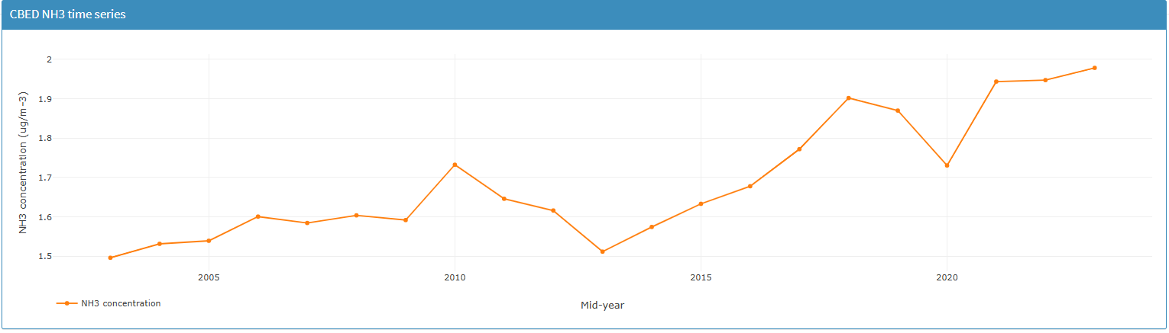
Figure 3. Long term trend in ammonia concentration for Bardney Lime Woods (from Air Pollution Information System, CEH, https://www.apis.ac.uk/app).

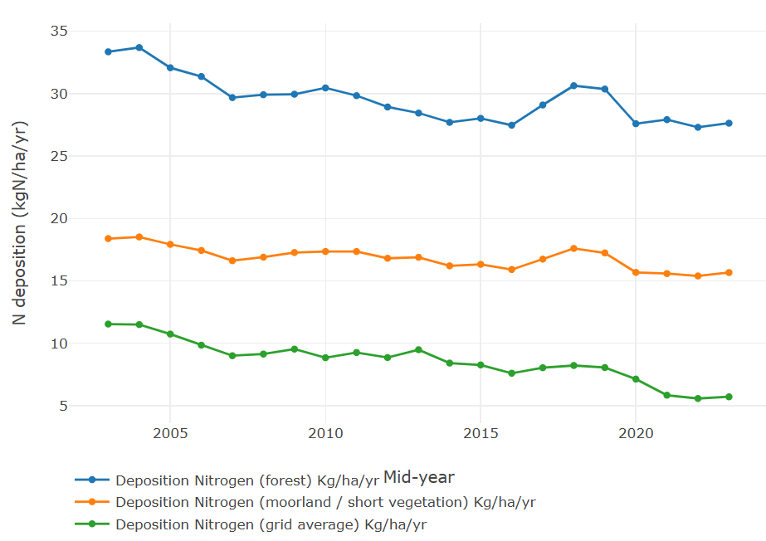
Figure 3. Long term trend in annual deposition of nitrogen for Bardney Lime Woods, (blueline plotted for forest habitat; Air Pollution Information System, CEH, https://www.apis.ac.uk/app).

3. Lack of suitable sensitivity testing of model estimates. – It is also important to note that considerable uncertainty exists regarding emissions modelling broadly, and therefore the Environment Agency has published guidance describing the use of sensitivity analysis to assess how sensitive the model results are to changes in assumptions, such as the use of different emission parameters (https://www.gov.uk/guidance/environmental-permitting-air-dispersion-modelling-reports#carry-out-sensitivity-analysis). For example, the current government-published emission factor used to model in-door broiler housing emissions is based on a single recent study (Mulvenna and Ball, 2024), which observes large variations in ammonia emissions between study sites and between poultry houses. Thus, a variety of emission factors selected from the range of possible values reported in the literature should be used in dispersion modelling to demonstrate the degree of uncertainty in model results and conclusions. This information shortfall must be redressed to better inform the authority about the expected emission impacts incurred by this development.

Conclusion: Additional information assessing the development’s impacts on designated local sites and priority habitats is required. This assessment should also include atmospheric dispersion model sensitivity testing that satisfies the requirements listed in : https://www.gov.uk/guidance/appropriate-assessment#what-must-an-appropriate-assessment-contain, and include the in-combination effects of emissions and odour impacts associated with manure spreading on third party land. This information would provide the basis for the authority to determine whether further conditions or constraints should be imposed on the development to reduce these impacts to an acceptable level, e.g., installation of air scrubbers and controls on waste spreading to reduce emissions and dust, etc.
In the absence of this information, I recommend that planning permission should be refused.

References
Caporn, S. et al. 2016. Assessing the effects of small increments of atmospheric nitrogen deposition (above the critical load) on semi-natural habitats of conservation importance. Natural England Commissioned Reports, Number 210.
Chapman, C. and Kite B. 2021. Guidance on Decision-Making Thresholds for Air Pollution. JNCC Report No.696 (Main Report), JNCC, Peterborough, ISSN 0963-8091.
CIEEM (2021) Advice on Ecological Assessment of Air Quality Impacts. Chartered Institute of Ecology and Environmental Management. Winchester, UK.
Guthrie, S. et al. 2018. The impact of ammonia emissions from agriculture on biodiversity: An evidence synthesis. The Royal Society, 76 pages. [https://royalsociety.org/~/media/policy /projects/evidence-synthesis/Ammonia/Ammonia-report.pdf].
IAQM. 2020. A guide to the assessment of air quality impacts on designated nature conservation sites. Institute of Air Quality Management [https://iaqm.co.uk/text/guidance/air-quality-impacts-on-nature-sites-2020.pdf].
Mulvenna, C.C., and Ball, M.E.E. 2024. Assessment of the ammonia emissions from conventional, mechanically ventilated broiler houses in Northern Ireland. Atmospheric Environment X23:1–7.
Rowe, E., et al. 2014. Measures to Evaluate Benefits to UK Semi-Natural Habitats of Reductions in Nitrogen Deposition. Final Report on REBEND Project (Defra AQ0823; CEH NEC04307). [https://uk-air.defra.gov.uk/assets/documents/reports/cat10/1511251351_AQ0823_REBEND_Final_report.pdf]

Thank you for your time, please get in touch if any further questions/concerns.

Chris De Ruyck, PhD, MNRM
Senior Ecologist
South & East Lincolnshire Councils Partnership
T: Mobile Number: 07394 837887
E: Chris.De-ruyck@e-lindsey.gov.uk
www.e-lindsey.gov.uk | www.sholland.gov.uk | www.boston.gov.uk | www.selcp.co.uk

Please note that any informal opinion expressed in this email is without prejudice and is not binding on the Council during the consideration of any formal application.

