Proposed residential development – 1 single storey 4 bed dwelling
Land south of 150 Broadgate
Whaplode Drove
Spalding
Lincolnshire
PE12 0TW

For Mrs. L. Minckley
Bambridge
Drove Road
Shepeau Stow
PE12 0TU.
Telephone: 01406 330287

Introduction

This application is to acquire outline planning permission for the erection of a single 4-bedroom, single storey dwelling on the land south of 150 Broadgate Whaplode Drove. The application site has a 60ft frontage on to Broadgate, Whaplode Drove, with a depth of approximately 120ft. This amounts to 0.067 hectares and is currently part of an agricultural field which fronts onto both Broadgate and Drove road (B1166). The application site is shown outlined in red on the plan below.

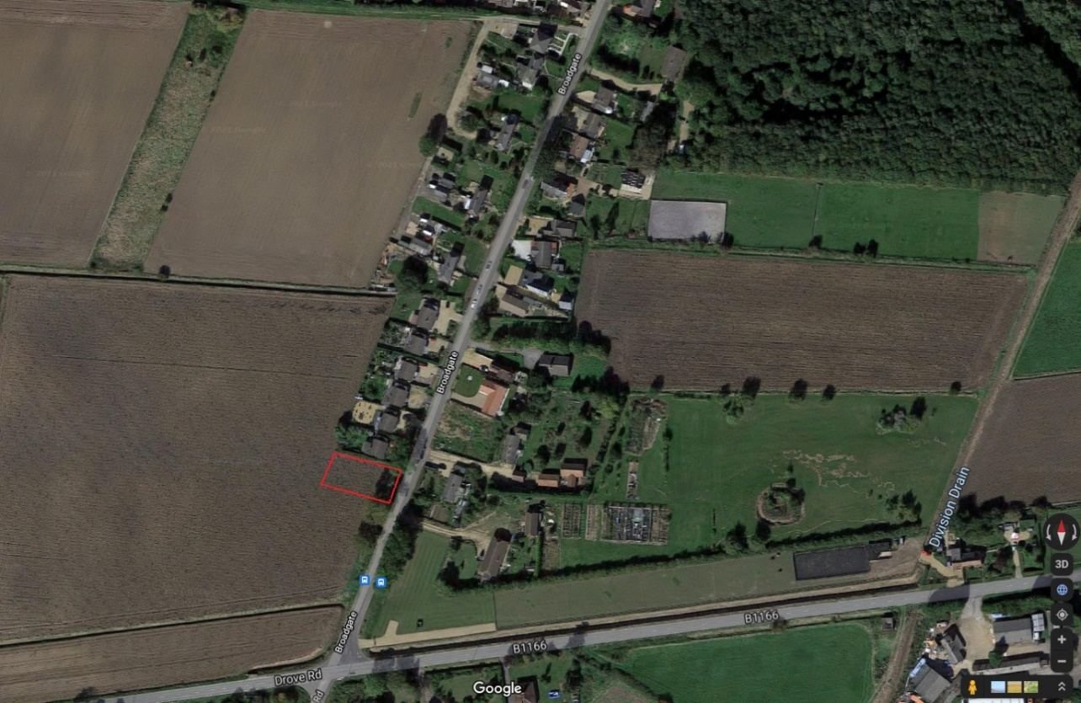
Figure 1 – Google Maps Image showing site in relation to Whaplode Drove
Opposite the application site is an area of open frontage onto Broadgate which has recently been developed into 2 single storey dwellings following planning permission H23-0446-17 (2-05-17).

The South East Lincolnshire Strategic Flood Risk Assessment maps, show the application site to be in zone 1, therefore a flood risk assessment is not required. Enclosed is a Flood Risk statement, alongside the location plan and flood maps provided by Geoff Beel, environment consultant.

This supporting statement should be read together with the following drawings (enclosed):
Flood Risk Statement
Location Plan scale 1:1250
Site Plan scale 1:500

The application site

The application site is located to the west of Broadgate and fronts onto Broadgate. The site is separated from Broadgate by a drainage dyke. Existing properties which abut the site have installed drainage pipes in the dyke to erect a driveway atop, which permits both drainage through the dyke and vehicular access to these properties.

The site is currently part of an agricultural field. Adjacent to the site there are a number of dwellings which are single storey. This theme continues opposite the site with further single storey dwellings, including the aforementioned development (H23-0446-17). Two trees are at the forefront of the site. To the West and South of the site is the remainder of the agricultural field.

There is a bus stop and postbox approximately 50m south of the site, both accessible via public footpath.

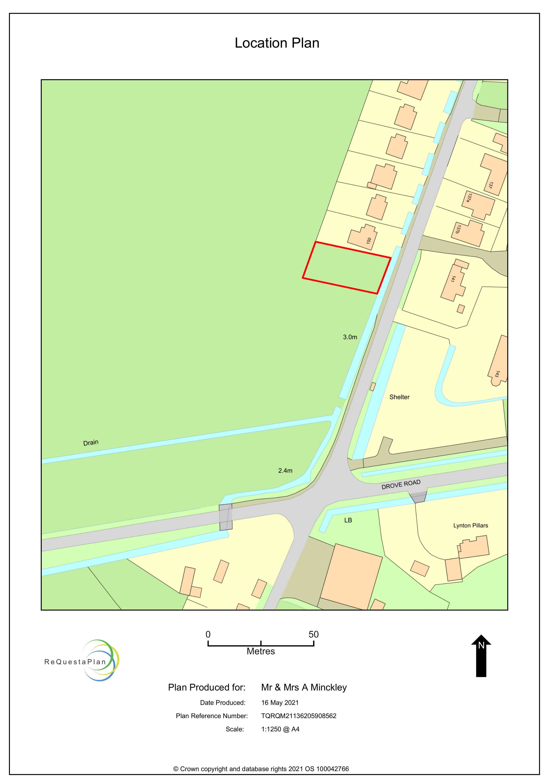
Figure 2 - Location Plan preview – please see enclosed for original to scale 1:1250

Planning Policy

The South East Lincolnshire Local Plan 2019 (SELLP 2019) policy 1 spatial strategy defines Whaplode Drove as “other service centre and settlement” and identifies a settlement boundary for Whaplode Drove.

The settlement boundary is drawn to exclude the application site and therefore the application site is designated as open countryside as per policy 1 spatial strategy, however dwellings opposite the application site are included.

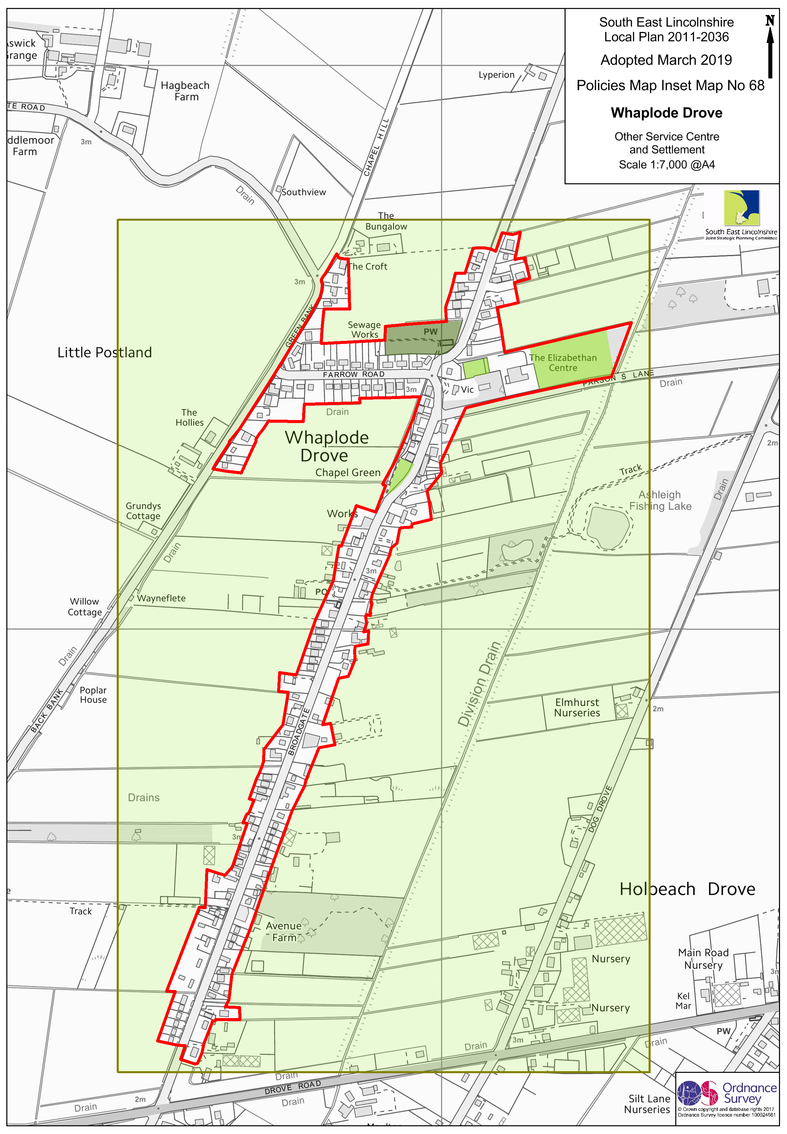
Figure 3 - Extract from SELLP 2019 – Inset map no.68 Whaplode Drove

In the South Lincolnshire Strategic Housing Land Availability Assessment – Whaplode Drove 2017, the site WHA 042 which was part of an agricultural field was deemed undevelopable “due to conflict with the emerging Plan’s locational strategy." This site WHA 042 has recently been granted planning permission H23-0650-18 (22-08-18) for 3 dwellings, despite the site being deemed undevelopable and classed as countryside as it is outside of the Whaplode Drove settlement boundary as defined by the SELLP 2019. This demonstrates that similar application sites, having been used for agricultural purpose, have received planning consent to develop beyond the settlement boundary of Whaplode Drove.

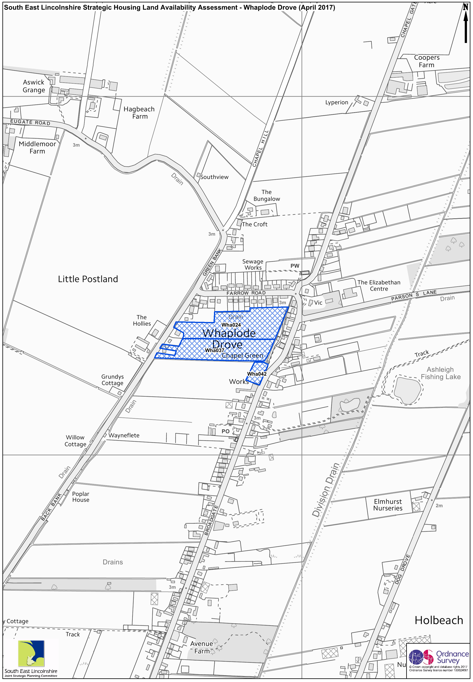
Figure 4 – Extract from South Lincolnshire Strategic Housing Land Availability Assessment – Whaplode Drove 2017.

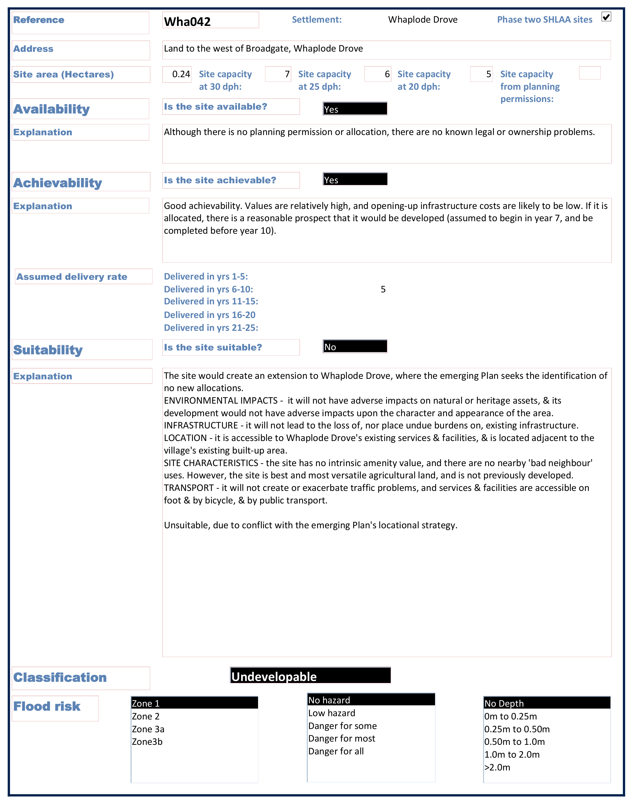
Figure 5 – Extract from South Lincolnshire Strategic Housing Land Availability Assessment – Whaplode Drove 2017.

If the application site were to be granted permission for a dwelling it would bring the settlement boundary on the West side of Broadgate in line with the East side, bringing uniformity to the southern boundary.
The National Planning Policy Framework 2019 (NPPF) sets out the governments planning policies for England and how these should be applied. The NPPF 2019 states in paragraph 11 “Plans and decisions should apply a presumption in favour of sustainable development.” The NPPF 2019 paragraph 8 outlines there are three objectives to sustainability; an economic role, a social role and an environmental role.

“a) an economic objective – to help build a strong, responsive and competitive economy, by ensuring that sufficient land of the right types is available in the right places and at the right time to support growth, innovation and improved productivity; and by identifying and coordinating the provision of infrastructure;

b) a social objective – to support strong, vibrant and healthy communities, by ensuring that a sufficient number and range of homes can be provided to meet the needs of present and future generations; and by fostering a well-designed and safe built environment, with accessible services and open spaces that reflect current and future needs and support communities’ health, social and cultural well-being;

c) an environmental objective – to contribute to protecting and enhancing our natural, built and historic environment; including making effective use of land, helping to improve biodiversity, using natural resources prudently, minimising waste and pollution, and mitigating and adapting to climate change, including moving to a low carbon economy.”

As the application site borders the settlement boundary, the SELLP 2019 aligns with the NPPF in that “countryside development will be permitted that is necessary to such a location and/or where it can be demonstrated that it meets the sustainable development needs of the area in terms of economic, community or environmental benefits.” (SELLP 2019 Policy 1 – spatial strategy D.)

The economic role identifies the need to ensure sufficient land of the right types is available in the right places and at the right time to support growth, innovation and productivity. The application site is identified in the SELLP 19 policy 1, spatial strategy C, as an “other service centre and settlement (as shown on the Inset Maps) development will be permitted that supports their role as a service centre for the settlement itself, helps sustain existing facilities or helps meet the service needs of other local communities.” The proposed dwelling will help to sustain facilities within the village, such as the post office and general store, WH Brand’s Garage, the Elizabethan Centre and local bus service from the bus stop located 50m from the application site. Nestled between Shepeau Stow and Holbeach Drove, it will also support growth in these neighbouring small settlements to sustain Shepeau Stow Primary School, Holbeach Drove general store and Giggles Galore children’s nursery.

The social objective identifies the need to ensure a sufficient number and range of homes can be provided to meet the needs of present and future generations. Predominantly, single storey dwellings within Whaplode Drove are 2/3 bedroom, and there is a short supply of 4 bedroom single storey dwellings for families who require 4 bedrooms and single level living, such as the applicant’s own family. The proposed dwelling will provide a suitable 4 bedroom single storey dwelling to assist in meeting the needs of both present and future generations, thus adhering to spatial strategy as outlined in the SELLP 2019 3.2 as settlements “can be expected to evolve, in a sustainable manner, to help meet the development needs of the area”.

The environmental objective identifies the need to protect and enhance our natural, built, and historic environment. The proposed dwelling would adhere to this, with a single storey dwelling infilling the land of neighbouring single storey dwellings on the West side of Broadgate to bring the settlement boundary in line with that of the East side of Broadgate. The proposal would therefore not be in conflict with SELLP 2019 3.2.14, which seeks to prevent incremental linear extensions of the settlement boundary. Careful design would ensure the new dwelling would use quality materials to harmonise within its village surrounding. The proposal would have a positive impact on the immediate vicinity.

The NPPF states in paragraph 78 “housing should be located where it will enhance or maintain the vitality of rural communities. Planning policies should identify opportunities for villages to grow and thrive, especially where this will support local services. Where there are groups of smaller settlements, development in one village may support services in a village nearby”. The proposed dwelling will adhere to this, providing support to sustain facilities within Whaplode Drove and neighbouring smaller communities of Holbeach Drove, Gedney Hill and Shepeau Stow which are also identified as other service centres and settlements in the SELLP 2019.

There is an opportunity to promote the use of public transport as outlined in paragraph 102 c of the NPPF 2019, with the nearest bus stop 50m away from the application site, which is accessible via a footpath. This provides public transport access to the nearby towns of Wisbech and Spalding, along with other nearby small settlement villages such as Gedney Hill and Sutton St. James. This footpath also gives access to facilities within Whaplode Drove, such as the post office and general store.

Therefore, the application site adheres as a sustainable development, with the presumption in favour of sustainable development as outlined in paragraphs 10 and 11 of the NPPF 2019.

Design and Access

Design
The design of the proposed dwelling is to be determined in reserved matters; however, the proposed design will ensure the character of the area is maintained.

Use
This outline application seeks to develop the site with a 4-bedroom detached single storey dwelling. A single storey dwelling will be in keeping with the immediate area, with single storey dwellings of varying size opposite and abutting the application site.

Size
The application site is 0.067 hectares. The depth of the application site is in line with existing dwellings which abut the site, reflecting the application sites suitability for development for a single storey dwelling.

Landscaping
Landscaping will be determined at reserved matters; however, it will endeavour to reflect the frontage given to existing dwellings which abut the site. Great care will be given to landscaping to incorporate and compliment the two trees at the forefront of the application site.

Access
The proposed dwelling will have access from Broadgate. The existing dyke at the front of the site will be proportionately piped to provide a driveway, and the existing footpath will have the curb lowered in co-operation with the local council. A turning point will be incorporated into the front drive, so vehicles may enter and leave the dwelling via a forward-facing position, onto Broadgate which has a speed limit of 30mph in place.

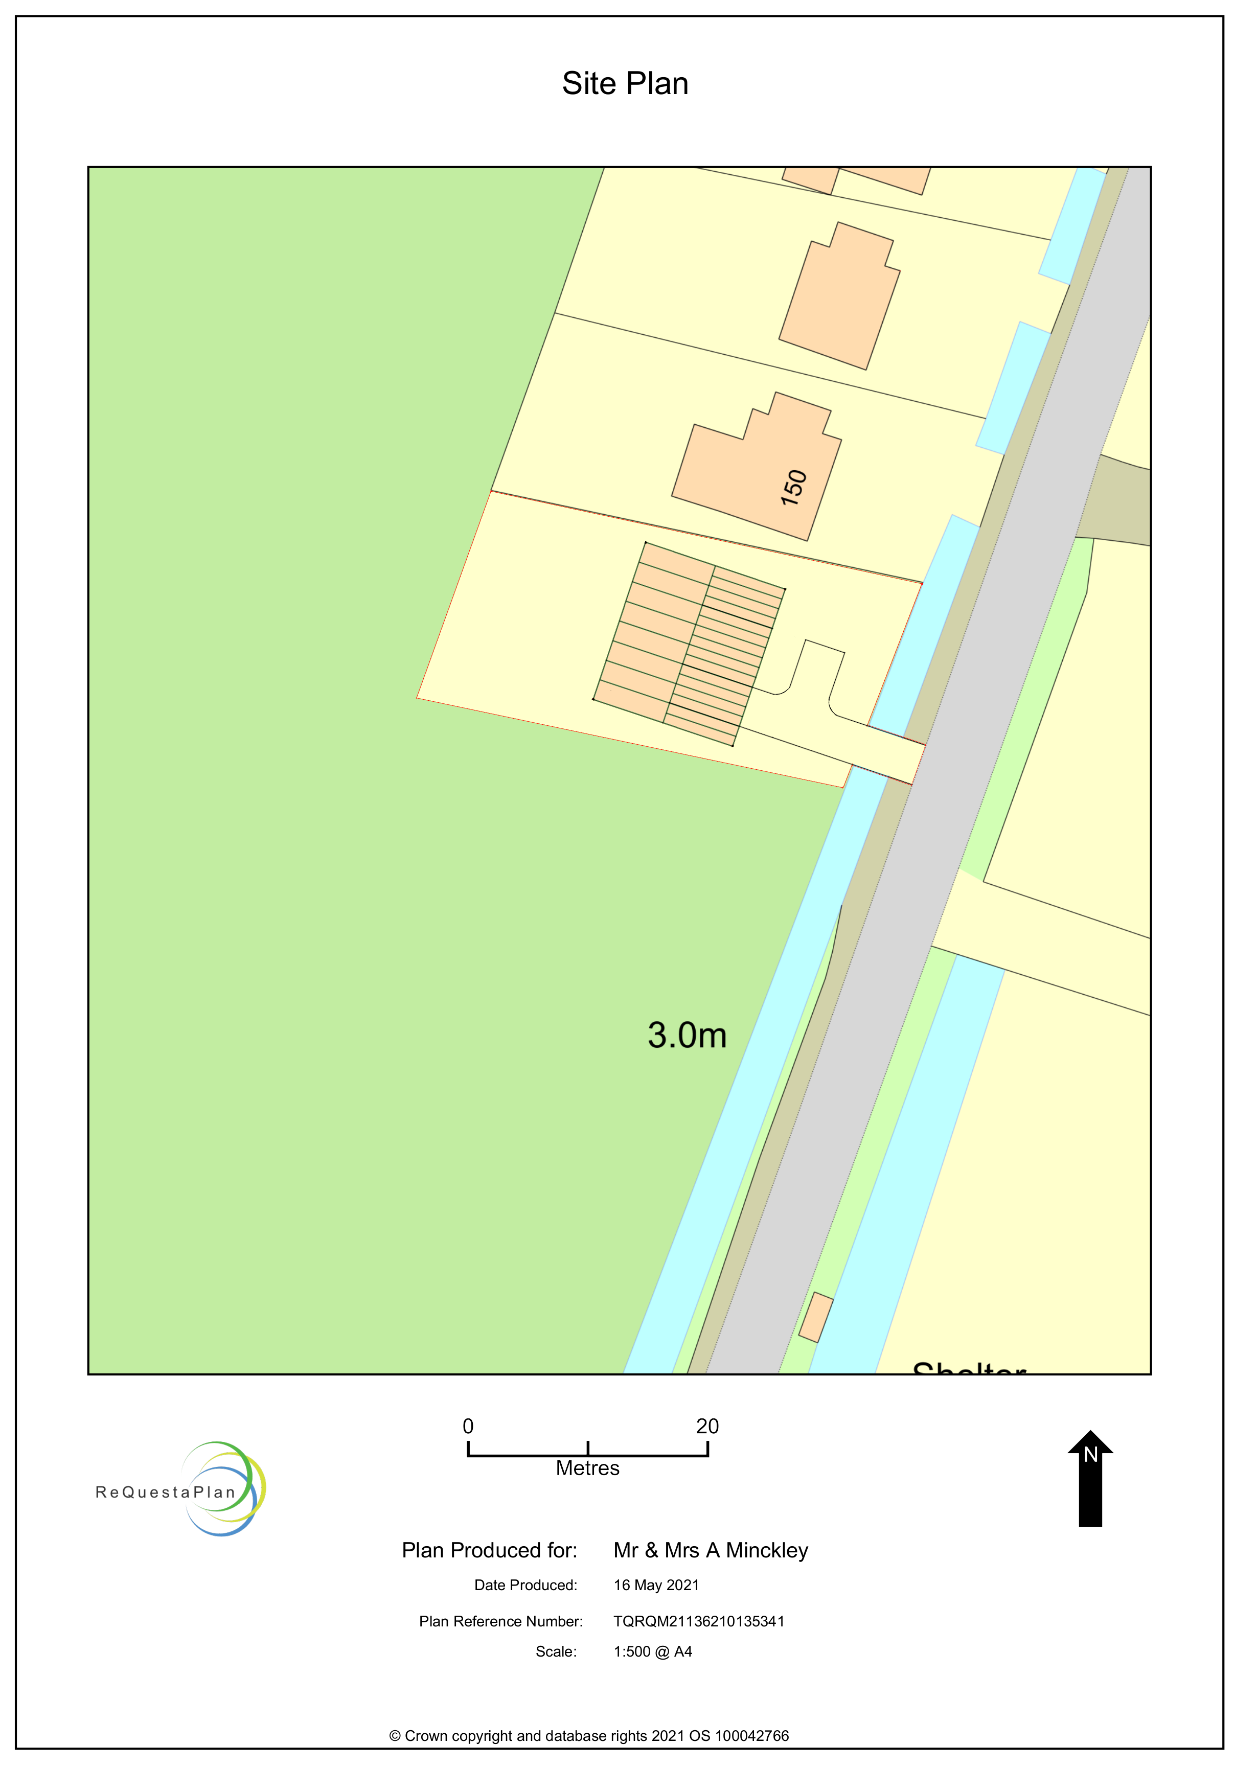
Figure 6 – Site Plan preview, please see enclosed for original to scale 1:500

Photos of the surrounding area
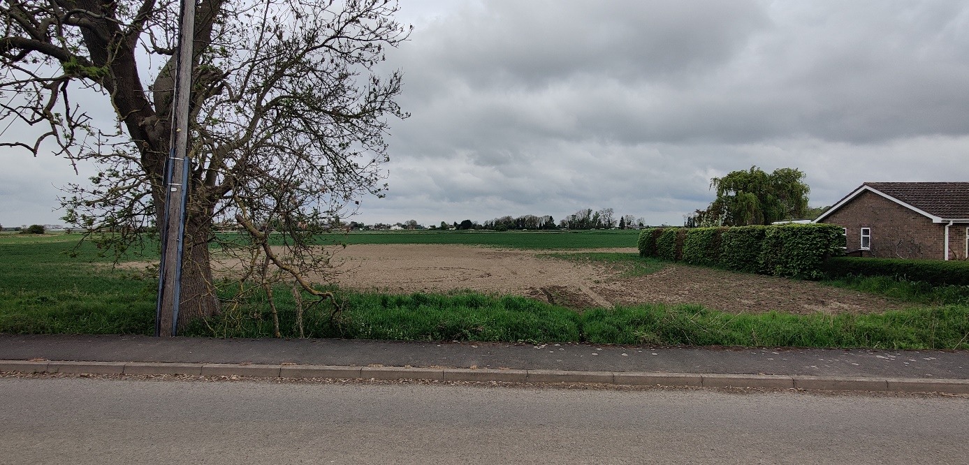
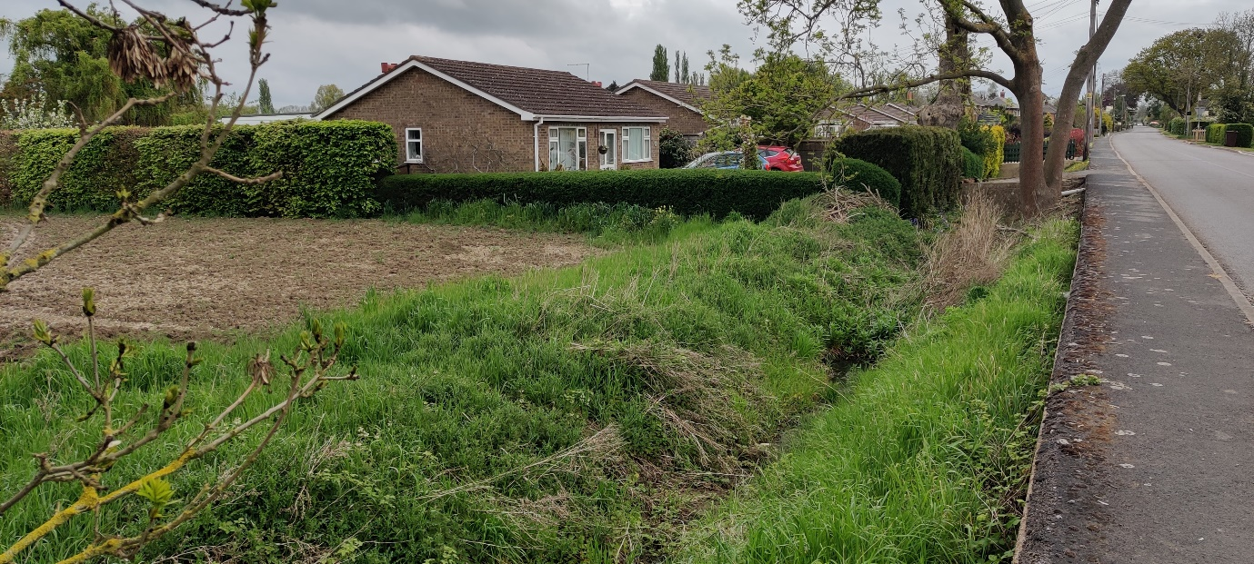
The Application site, with abutting dwelling.

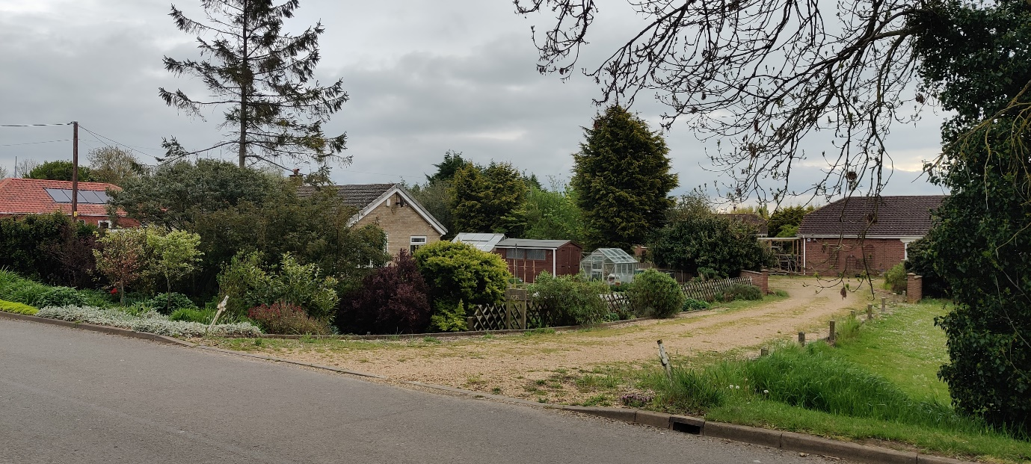
Dwellings opposite the application site.
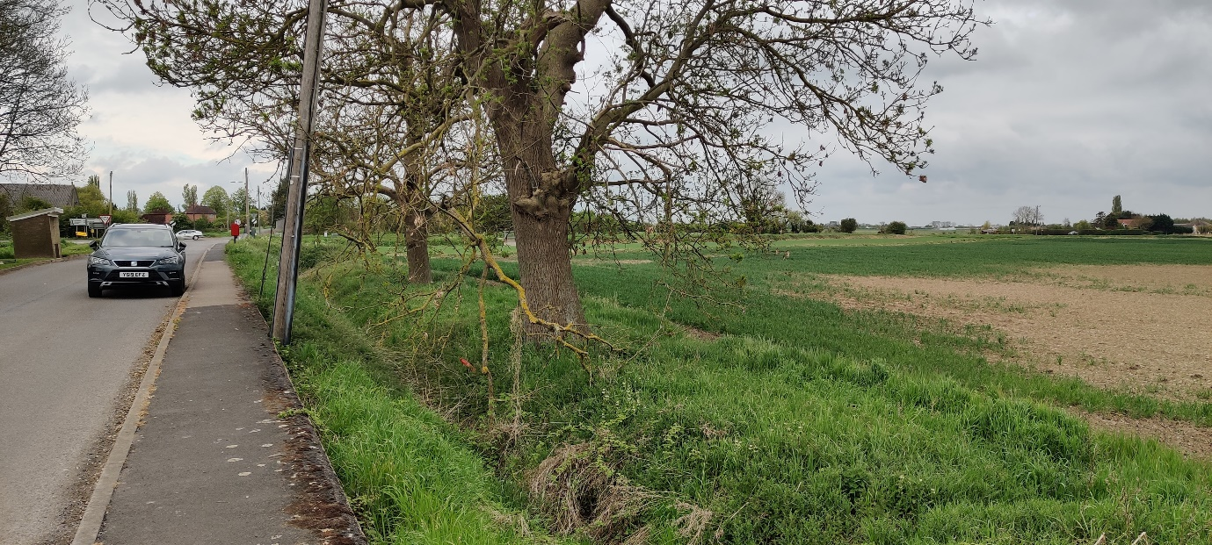
Proximity of bus stop and Post-box accessed via footpath in relation to the application site.

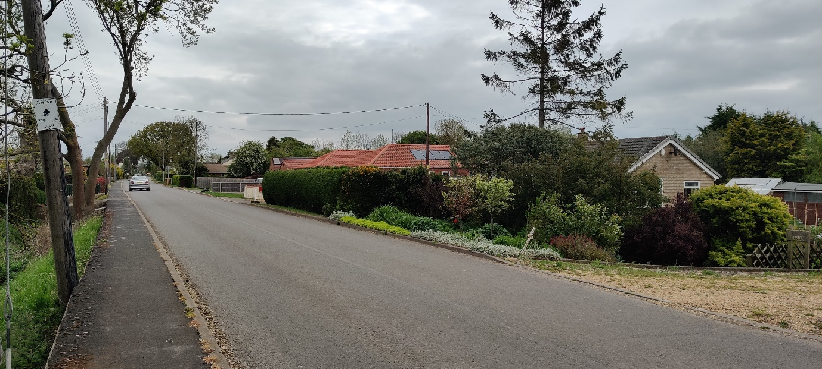
North view of Broadgate from application site.

