Report for Mr. & Mrs M. Seymour
Flood Risk Assessment
SITE REPORT VIA DESK BASED RESEARCHE
Garry Winterton BSC (HONs. MB Eng.
10-20-2020

Conversion of Farm Buildings, Desk Study Report
20 September 2021 FINAL REV0

Project 270755-MJS

CONTENTS

- Limitations

- Executive summary

- Introduction, purpose & objectives

- Site location & description

- Existing site

- Proposed development

- Flood map for planning

- The design flood

- Preliminary flood risk assessment

- Strategic flood risk assessment

- Surface water management strategy

- Foul water

- Groundwater flood risk

- Flood risk from reservoirs & large waterbodies

- Desk based study assessment

- Conclusions and recommendations

- Photos

Farm Buildings
Childers.
26 High Street.
Whaplode,
Spalding.
PE12 6UA

Our Ref No. 270755-MJS

Date: 21 September 2021

Desk Study Report

Limitations
All comments and proposals contained in this report, including any conclusions, are based on information available to G. Winterton during investigations. The conclusions drawn by G. Winterton could therefore differ if the information is found to be inaccurate or misleading. G. Winterton accepts no liability should this be the case, nor if additional information exists or becomes available with respect to this scheme. Except as otherwise requested by the client, G. Winterton is not obliged to and disclaims any obligation to update the report for events taking place after: - (i) The date on which this assessment was undertaken, and (ii) The date on which the final report is delivered G. Winterton makes no representation whatsoever concerning the legal significance of its findings or the legal matters referred to in the following report. All Environment Agency mapping data used under special license. Data is current as of February 2017 and is subject to change. The information presented and conclusions drawn are based on statistical data and are for guidance purposes only. The study provides no guarantee against flooding of the study site or elsewhere, nor of the absolute accuracy of water levels, flow rates and associated probabilities. This report has been prepared for the sole use of Mr. & Mrs. Seymour. No other third parties may rely upon or reproduce the contents of this report without the written permission of G. Winterton. If any unauthorised third party comes into possession of this report, they rely on it at their own risk and the authors do not owe them any Duty of Care or Skill.

EXECUTIVE SUMMARY
This Flood Risk Assessment (FRA) has been prepared in accordance with the requirements set out in the National Planning Policy Framework (NPPF) and the associated Planning Practice Guidance. It has been produced on behalf of Mr. & Mrs. Seymour. in respect of a planning application for the change of use of two existing farm storage buildings into dwellings.

This report demonstrates that the proposed development is not at significant flood risk, subject to the recommended flood mitigation strategies being implemented. The site is indicated to lie within Flood Zone 3, Pluvial and groundwater flood risk possible.
The significant distance and topographical barriers lying between the site and any river indicate that any fluvial flood risk posed can be considered to be low.
In terms of pluvial flood risk, Environment Agency mapping indicates that the site is within an area surrounded by high risk of surface water flooding to the north, east and west. Within the site boundary there is shown to be low to moderate risk of surface water flooding. Surface Water modelling and historic records of flooding within the area show no indication of flooding.

There will be no increase in impermeable surfacing from the proposed development and consequently no increase in surface water runoff or volumes to existing. No sources of flood risk such as reservoir, canal and groundwater have also been reviewed and are not considered to pose a risk to the site.
In compliance with the requirements of National Planning Policy Framework, and subject to the mitigation measures proposed, the development could proceed without being subject to significant flood risk. Moreover, the development will not increase flood risk to the wider catchment area as a result of suitable management of surface water runoff discharging from the site.

INTRODUCTION, PURPOSE & OBJECTIVES

This Flood Risk Assessment (FRA) has been prepared in accordance with the requirements set out in the National Planning Policy Framework (NPPF) and the associated Planning Practice Guidance.

The report has been undertaken to its suitability for the proposed development.

The purpose of this report is to provide an overview of the flood risk assessment context of the site via various desk-based searches and a walkover assessment.

SITE LOCATION & DESCRIPTION

Sources of Data
The report is based on the following information:
- Proposed Plans by G.R. Merchant Ltd, reference [Dwg. No. 05A]
- OS Explorer Series mapping
- Environment Agency mapping
- Web Based Soil Mapping
- Anglian Water Sewer Records
- British Geological Survey Drift & Geology Maps

The study area and location are presented in Appendix A. A walkover survey was undertaken in September 2021. The site is centered on O.S. Grid Reference 533976, 324745 The plot has an approximate area of 0.27 hectares. (2775m²)

The site has been occupied by Mr. & Mrs. Seymour. The site has two buildings and has been used for agricultural purposes as far back as records show. The ground conditions consist of approximately 11.5m of medium density silt sand 183 to 204 million years ago in the Jurassic and Triassic periods with 600mm of topsoil. Local environmental previously dominated by shows this general make up of ground conditions.

There are no records of major flooding in this area despite the area falling within the zone 3 floor area according to the EA flood maps.

It should be noted Mr. & Mrs. Seymour also own the land directly encompassing the site. Photographs were taken and are presented in Appendix B.

Existing Site

Many maps previously issued by the Ordnance Survey were examined. No record of any previous development prior to the farm buildings was found. This is largely within the flood zone 3 area, but all the land adjacent has been developed. It should be noted that there has been no flooding of the site since within living memory.

The area does not appear to fall within the Petroleum Exploration Development License (PEDL) block.

The property itself is not listed. The details of the existing buildings within the proposed change of use together with all relevant levels will be submitted as part of the architect’s submission.

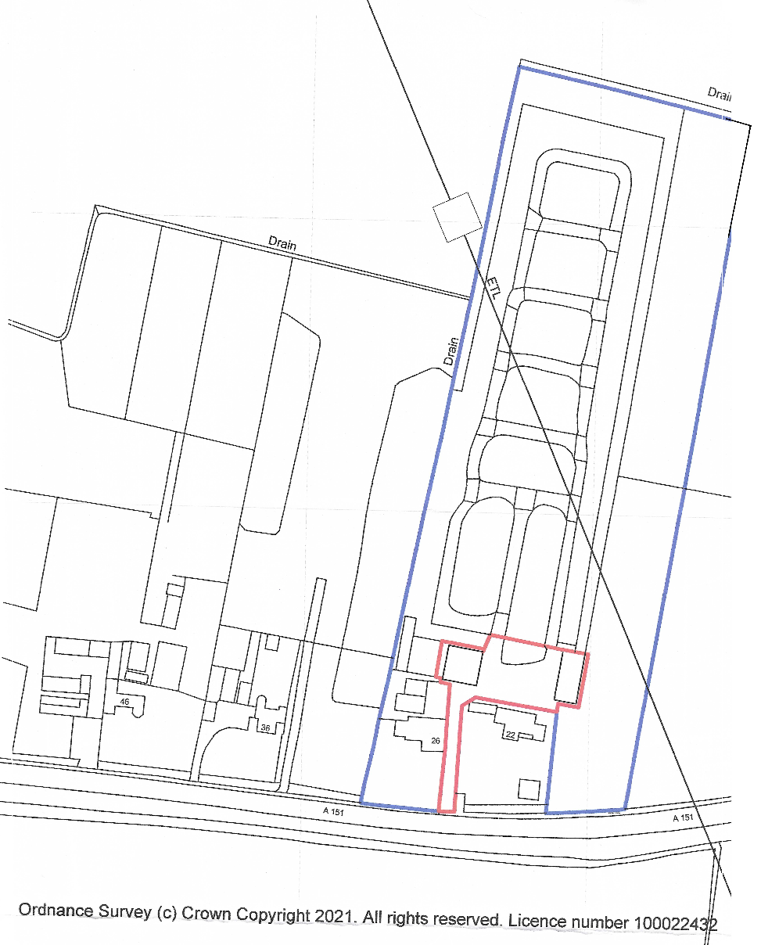
Appendix A

Proposed Development
The development proposals are intended to be a single storey dwelling and a two-storey dwelling. These through a change of use from agricultural buildings to dwellings.

FLOOD RISK PLANNING POLICY

Proposed Development
The NPPF1 sets out the Government’s national policies on different aspects of land use planning in England in relation to flood risk. Planning Practice Guidance is also available online 2.
The Planning Practice Guidance sets out the vulnerability to flooding of different land uses. It encourages development to be located in areas of lower flood risk where possible and stresses the importance of preventing increases in flood risk off site to the wider catchment area.
The Planning Practice Guidance also states that alternative sources of flooding, other than fluvial (river flooding), should also be considered when preparing a Flood Risk Assessment.
The Planning Practice Guidance also includes a series of tables that define Flood Zones
the flood risk vulnerability classification of development land uses
and ‘compatibility’ of development within the defined Flood Zones
.
This Flood Risk Assessment is written in accordance with the NPPF and the Planning Practice Guidance.

Flood Map for Planning
With particular reference to planning and development, the Flood Map for Planning produced by the Environment Agency identifies Flood Zones in accordance with Table 1 of the Planning Practice Guidance.
- Flood Zone 1 (Low Probability) is defined as land having less than a 1 in 1000 annual probability of river or sea flooding (<0.1%).
- Flood Zone 2 (Medium Probability) is defined as land having between a 1 in 100 and 1 in 1000 annual probability of river flooding (1% - 0.1%); or between a 1 in 200 and 1 in 1000 annual probability of sea flooding (0.5% - 0.1%).
- Flood Zone 3a (High Probability) is defined as land having a 1 in 100 or greater annual probability of river flooding (>1%); or land having a 1 in 200 or greater annual probability of flooding from the sea (>0.5%). This is represented by “Flood Zone 3” on the Flood Map for Planning.

Flood Zone 3b (The Functional Floodplain) is defined as land where water has to flow or be stored in times of flood. This is not identified or separately distinguished from Zone 3a on the Flood Map for Planning.

The study site is shown to be located entirely within Flood Zone 3 as shown on map below

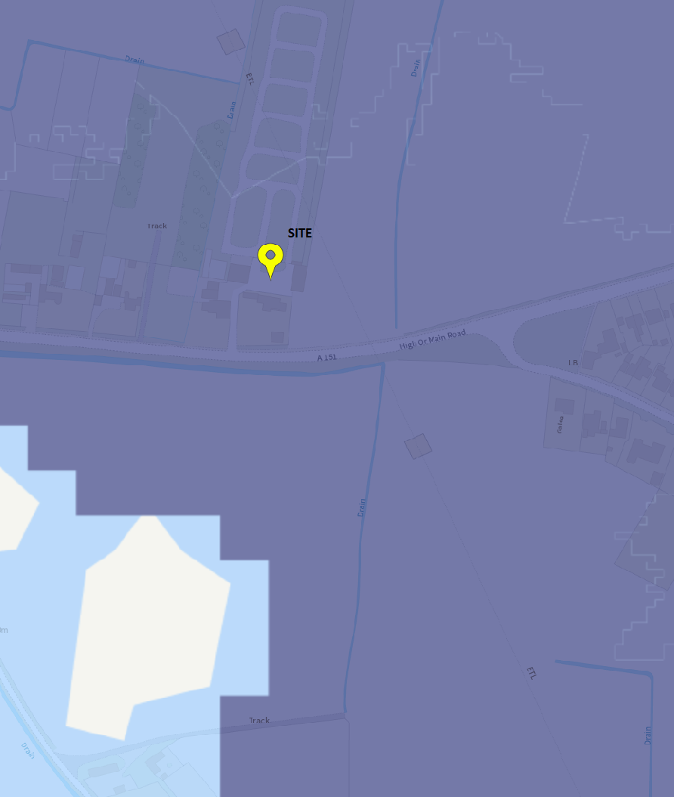

Environment Agency Flood Map

The Design Flood
The Planning Practice Guidance identifies those new developments should be designed to provide adequate flood risk management, mitigation, and resilience against the ‘design flood’ for their lifetime.
This is a flood event of a given annual flood probability, which is generally taken as fluvial (river) flooding likely to occur with a 1% annual probability (a 1 in 100 chance each year), or tidal flooding with a 0.5% annual probability (1 in 200 chance each year), against which the suitability of a proposed development is assessed and mitigation measures, if any, are designed.

Planning Practice Guidance classifies land use. Under the classifications for the proposed development use and taking a conservative approach from the greatest vulnerability classification for proposed use; retail and restaurant the site can be considered to be ‘More Vulnerable’.
Planning Practice Guidance identifies that a ‘More Vulnerable’ development within Flood Zone 3 is considered to be ‘appropriate’.

Preliminary Flood Risk Assessment
A Preliminary Flood Risk Assessment (PFRA) is an assessment of floods that have taken place in the past and floods that could take place in the future. It generally considers flooding from surface water runoff, groundwater and ordinary watercourses, and is prepared by the Lead Local Flood Authorities.
Considers flooding from surface water runoff, groundwater, ordinary watercourses and canals. It also references the historical river flooding which occurred in the local area. However, no historical instances of flooding at the site are referenced.

Strategic Flood Risk Assessment
A Strategic Flood Risk Assessment (SFRA) is a study carried out by one or more local planning authorities to assess the risk to an area from flooding from all sources, now and in the future.
This was produced to facilitate the application of Sequential and Exception Tests to screen allocated development sites. The proposed application site is not referenced within the SFRA, however this document provides information which is still relevant to the following proposals.

Surface Water Management Strategy
A surface water management strategy and long-term action plan for the management of local surface water flood risk. The surface water from the existing buildings is dispersed through soakaways and it is intended to continue to use the existing system which still meets the Environment Agency design philosophy.

Foul Water
All FW within the sight will be through the use of mini treatment plants so there is no added risk of flooding through these.

Groundwater Flood Risk
Groundwater flooding occurs when the water table rises above ground elevations. It is most likely to happen in low lying areas underlain by permeable geology. This may be regional scale chalk or sandstone aquifers, or localised deposits of sands and gravels underlain by less permeable strata such as that in a river valley.
Online British Geological Survey (BGS) 1:50,000 scale geological mapping (Figure 3.1) indicates that the surrounding bedrock comprises Terrington Beds: younger marine alluvium; salt marsh, tidal creek and river deposits (sandy silt, sand and clay)

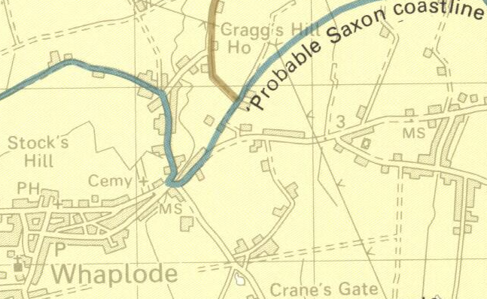
Approximate
Site Location
Figure 3.1

Flood Risk from Reservoirs & Large Waterbodies

There are no Reservoirs & Large Waterbodies within the area which could affect thew development.

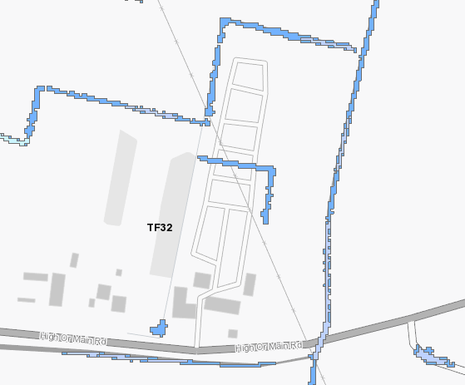
Approximate site location
Risk of Flooding from Surface Water Mapping (Scale 1:5,000)

DESK BASED STUDY ASSESSMENT
The data collated from site has been assessed and the following possible receptors have been considered within a ‘conceptual model’. This is a summarised assessment which outlines the potential issues within or near the site that may impact the proposed development.

CONCLUSIONS AND RECOMMENDATIONS
This Flood Risk Assessment (FRA) has been prepared in accordance with requirements set out in the National Planning Policy Framework (NPPF) and the associated Planning Practice Guidance. The FRA has been produced on behalf of Mr & Mrs Seymour in respect of a planning application for the proposed change of use of two detached agricultural buildings into dwellings
This FRA is intended to support a planning application for the following site and as such the level of detail included is commensurate and subject to the nature of the proposals.
This report demonstrates that as with all the new proposed development within this group 3 flood zone there is no historical history of flooding. Therefore, it can be concluded there is not at significant flood risk, subject to the recommended of minimum floor levels and flood mitigation strategies being implemented.

Phots

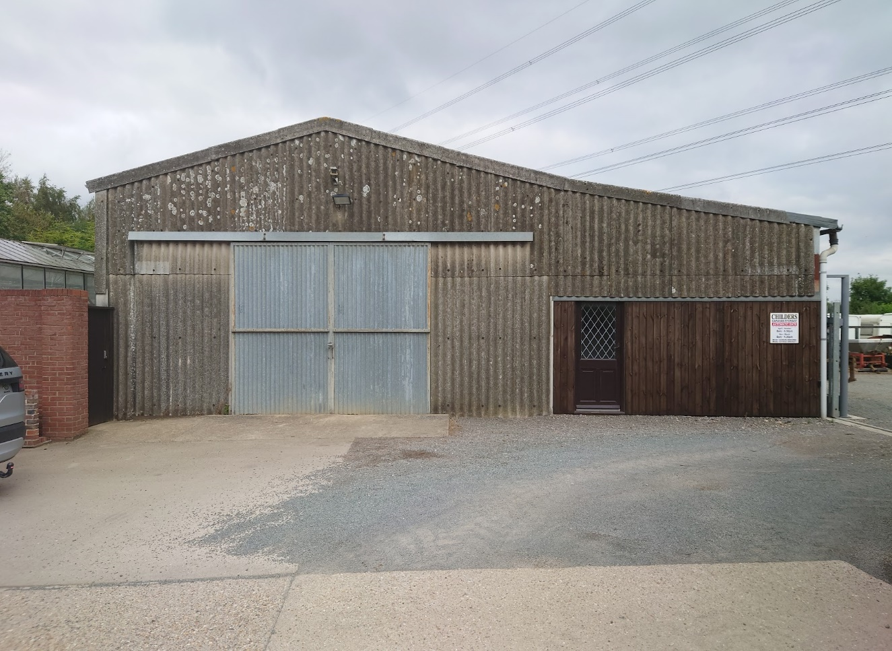

Storage Barn 1

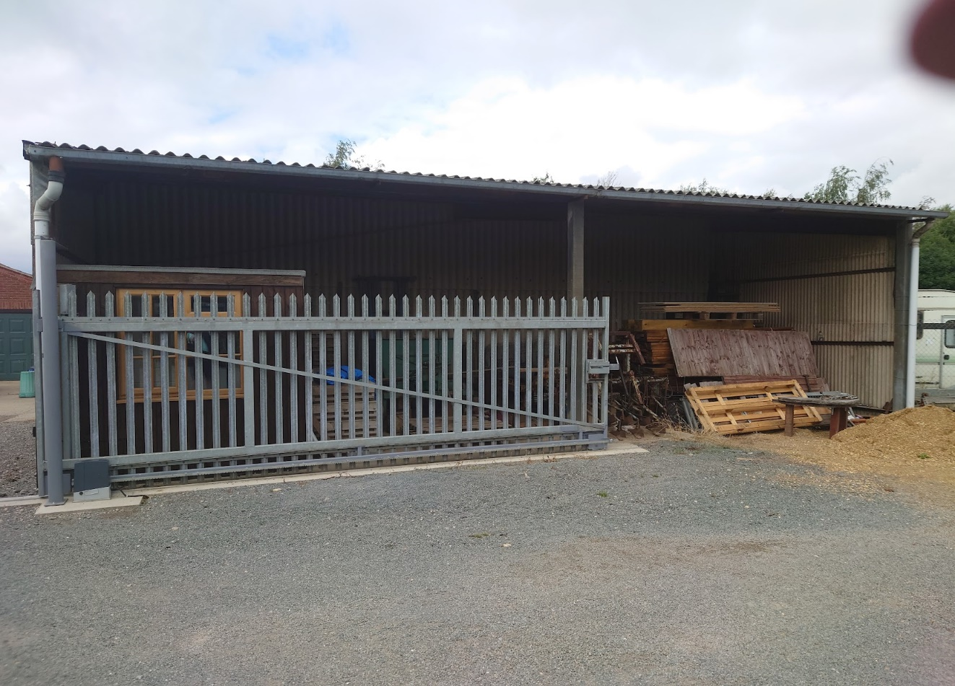

Storage Barn 1

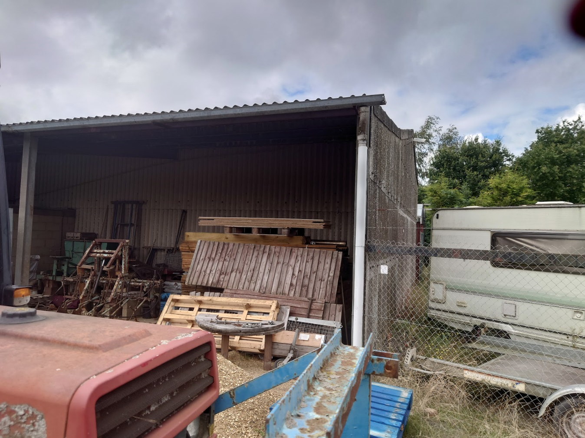

Storage Barn 1

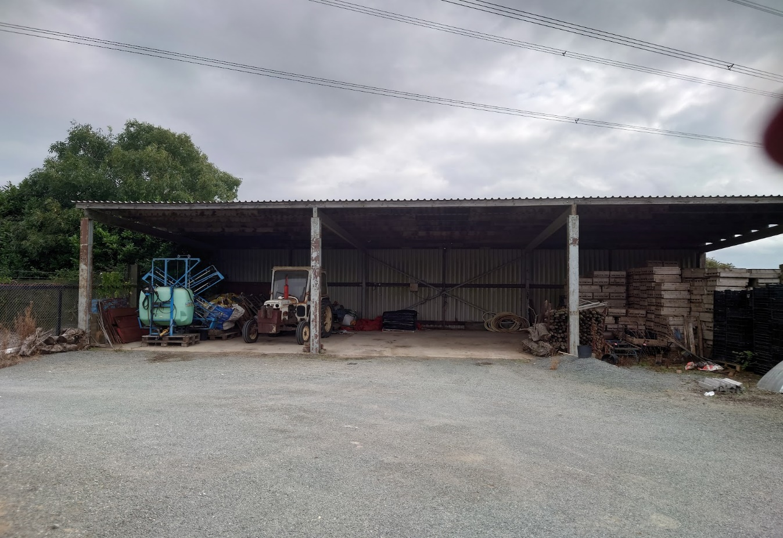

Storage Barn 2

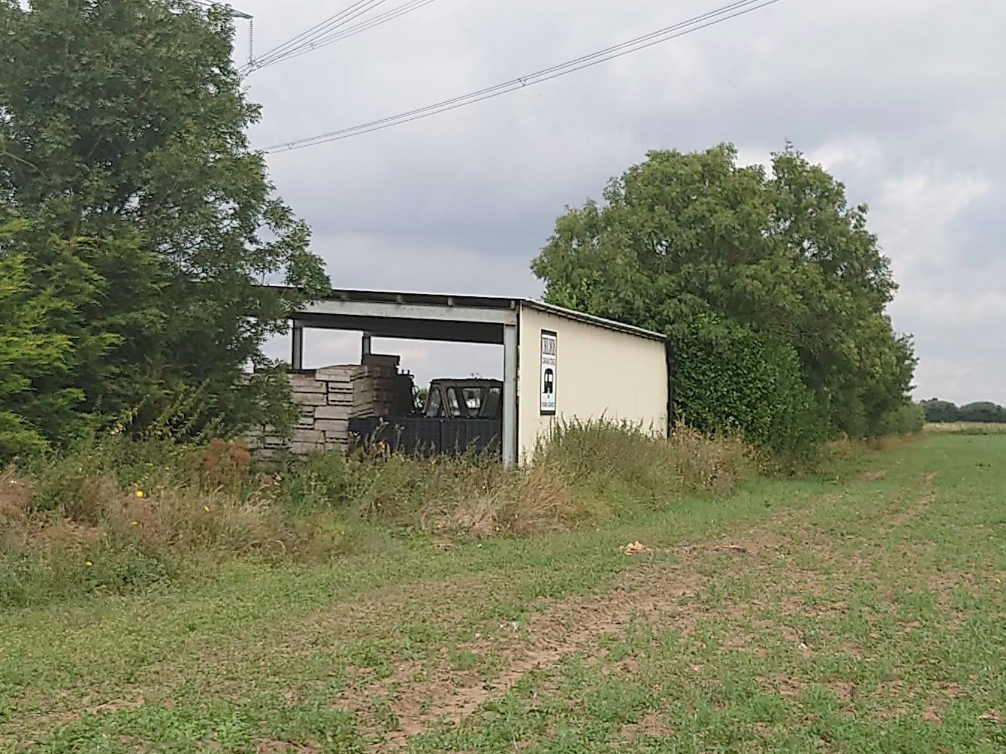

Storage Barn 2

